*此文档用于Interview questions整理和总结：*

***CORE JAVA 1:***

**What is JVM:**

Java can be running in the JVM, like a fish swimming in a pool, it doesn't matter what operating system is. It is the java running environment. JVM(environment) < JRE(libraries) < JDK(compile .java file to .class file, document).

**Memory:**

Stack(small): reference

Heap(大): object.

**How does maven work?**

Maven downloads the dependency depending on the pom.xml from the cloud to manage the dependencies in the project.

Maven build-in function: mvn clean package command clears the target directory and Builds the project and packages the resulting JAR file into the target directory.

mvn clean install command clears the target directory and builds the project described by your Maven POM file and installs the resulting artifact (JAR) into your local Maven repository.

<https://www.tutorialspoint.com/maven/maven_repositories.htm>

Maven repository search order: local -> Central -> Remote? Or local -> Remote ->Central?

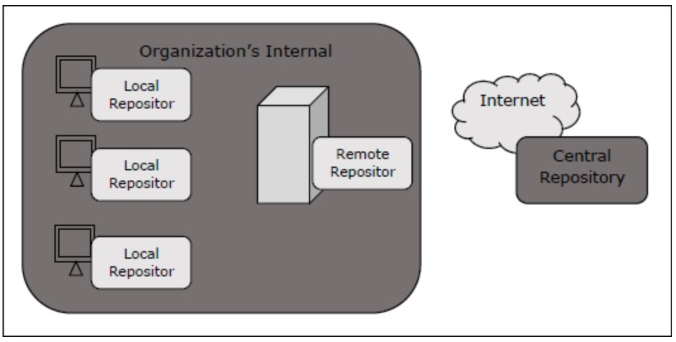

**What is a constant pool/string pool?（X）**

Constant pool has one unique string, double quote will create a string in the constant string pool, but the keyword “new” will create a string in heap. Constant pool is also in the heap.

**Memory Leak?**

Memory leak is something always in the memory but not cleaned by the garbage collection system. Like a static list is still pointed by the original reference, never be used. It will always be in the memory.

**Difference between heap and stack?()**

Heap includes the young generation, old generation and permanent Generation based on object age, which means how long it stays.

In general, Heap Space is for storing the objects and JRE classes.

Stack memory is used to store items which have a very short life like local variables, a reference variable of objects.

**How many objects in the constant pool?**

When string abc is creating a string using “”(double quote) in the constant string pool, it will check if the string abc is already in the string pool. If it exists, put a reference to that. Otherwise, create a new one.

**What is the difference between string str1 = “abc” and str2 = new String(“abc”)?**

Str1 is created in the string pool, but the str2 is created in the heap memory.

**What is the difference between string vs stringbuilder vs stringbuffer?**

String is immutable, but stringbuilder and stringbuffer are mutable.

Stringbuilder is not thread safe, stringbuffer is thread safe.

What is thread not safe? For example, there is only one movie ticket, but if two people can buy the same movie ticket, it is not thread safe. If only one person can buy the movie ticket, that is thread safe.

**What is the difference between ==(equal sign) and equals method?**

Equal sign is to compare the reference of the object, equals() method is to compare the value of the object. Most of the time we need to override the equals method.

**What is StringTokenizer?(推荐用split 代替)**

It is the method that can separate a string. It has hasMoreTokens method and nextToken method so that it is easy to get the certain part of the string.

**What does the final keyword mean?**

Final can be used on the field of a class, on the class name, or on the method of a class. It means the final value can not be changed.

1. If the final keyword is added on a string, like a final String name is “jack”, the name can not be changed to Bob.
2. If the final keyword is added for the object type, like a final List is already initialized using new ArrayList<>(), the content in this list can be changed, but the list can not be initialized by using a new keyword again.
3. If the final keyword is added to the method of a class, it will not be overridden in the subclass of this class.
4. If the final keyword is added to a class, it will not be extended.

**What is the difference between final, finally and finalize?**

**Final** means the final value can not be changed. 1. Method can’t be overridden. 2. Class can’t be extended. 3. Field is constant.

**Finally** is used in the try catch finally block, the code in the finally block will always be executed.

**Finalize** will inform the garbage collection to recycle waste.

**How to make a class immutable?**

Three steps:

1. Make the final class.
2. Make the fields in the class private, so it is accessible only inside.
3. Do not give the setter method.

***CORE JAVA 2:***

**When/How to use** ***static*?**

Static is often used on the Utils, or helper class which does not need to set the value of a field, it is just to do some logic operation. So it can be used in the other instance of class by using ClassName.methodName, but there is no need to create the instance of the class. So it can save memory and reduce the duplicate coding.

Static can be used on a field, method or as a static block. Static blocks will be loaded immediately when the class is created.

Father Static block -> son’s static block -> father static field/method -> son static field/ method - > father field - > father constructor -> son field -> son constructor.

**What is a static keyword?**

If the address field in the employee class is static, it means there is only one address in the class, no matter how many employee objects are created. We can call it class variable or static variable.

Static keywords can be used on the field of a class.

Also it can be used like a static block, the code in the static block will be created when the class is loaded before the object constructor works so that it makes sure the data in the static block is ready when the application is running.

**List some Common static methods in java?**

Math.max(), Collections.sort(), Arrays.sort()

**Can static methods access non-static methods?**

No.

**What is OOP?**

Polymorphism: override, overload, 大 = 小。

Inheritance: extends, implements,

Encapsulation: black box, we do not need to care about the implementation of the box, it just provides an API for others to use.

**What is the difference between abstract class and interface?**

(1. class has concrete methods--has implementation. 2.interface has all abstract methods -- no implementation. 3. abstract class has both.)

Abstract class should have concrete methods and abstract methods and fields.

Interfaces only have abstract methods and fields.

Abstract class does not support multiple inheritance, but interfaces can do multiple implementations.

Abstract class has its constructor while interface doesn't have it.

Abstract class can have abstract method and non-abstract method, while interface can only have abstract method.

**What is the interface?**

The interface should include something abstract. When a class implements an interface, it should implement all the methods in the interface. One class can implement more than one interface, even the methods defined in different interfaces are the same. Every interface only cares about if the class implements all the methods in the class, don’t care about if they are the duplicate.

**What is a marker interface?**

Marker interface is the interface in which there is no abstract method. Like serializable, cloneable.

**What is inheritance?**

There are 2 types of inheritance.

First is to extend from class, only one class is only allowed to extend one class. Java does not allow multiple inheritance.

Second is implementing an interface. One class is allowed to implement more than one interface.

**What is multiple inheritance? Does Java support it?**

Multiple inheritance is one class inherits (extends) from multiple different classes. Java doesn’t support it, but it can be achieved by implementing multiple interfaces.

**List an example for abstraction?**

ATM. We can save money or withdraw money from an ATM, but we do not know how the ATM works inside. It provides the service to users but doesn't care about the internal implementation logic.

**What is polymorphism?**

Static polymorphism (compile-time), overload in the same class, means the same method name in the same class but has different parameters.

Dynamic polymorphism (run-time), override in the child class, means the parent class method is implemented differently in the child class.

**What is encapsulation?**

Wrapping some fields and methods into one unit, using getter and setter instead of direct access.

**The difference of the four access modifiers?**

Two same name classes can not be in the same package.

Access modifier: default, protected, private, public.

Default scope is only to care about if it is in the same package.

Protected scope is to care about if it is the subclass no need to care about different packages.

**What is serializable?**

When we try to send json data from the backend to a database system or file system, we need to convert the json data to binary string to keep the data integrity or constant, we can implement the serializable interface which is a marker interface. We don’t need to implement any method in the serializable interface. The serialVersionUID is for serialization and deserialization. serialVersionUID is no need to define, it can be created automatically. Transient keyword is to avoid serialization.

**Why static fields or classes can not be serialized?**

Because the static fields or classes are class level, serializable is for the object.

As class level values they are "global" to all instances of that class.So what would be the "correct" value when deserializing several instances of such class? There can only be one instance of such values. So static fields are linked to the class and are serialized and deserialized with the class itself not with the different instances.

Static Integer i = 11;

**Design pattern (Singleton)?(要会写一个，或者说出来)**

Java is not allowed to define a static outer class, but we can get it as a singleton.

Singleton means it can only be one instance.

Step 1: you need to make the constructor private, so that you can not make an instance from the constructor.

Step 2: you need to provide a getInstance() method to return the only one instance. But you need to add the method static to use the ClassName.getInstance to get the instance, add the method synchronized is to make thread safe.

Step 3: you need to override the clone() method to prevent Object.clone(singleton) to get the instance.

Step 4: override the readResolve() method to prevent serialization or deserialization. Because after serialization and deserialization, the object will be different from the original object.

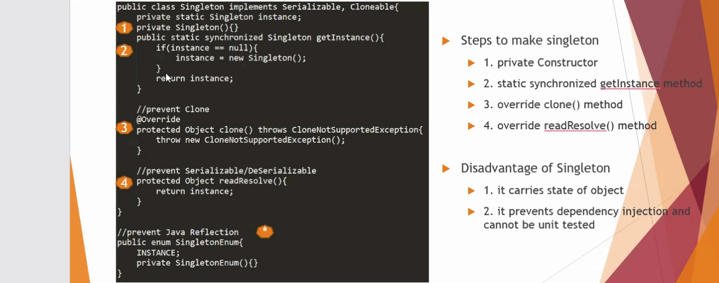

***CORE JAVA 3:***

**What is factory design pattern/ give an example? （尽量会写一个例子**）

Good example: <https://programmer.ink/think/factory-pattern-of-23-design-patterns-java-language.html>

A factory is the tool that can provide different types of subclass.

When an application wants to connect different databases, we can design a DBconnection Factory. First we should have a DBconnection interface in which we need an abstract method getConnection() method. So oracleConnection can implement the DBconnection interface, in oracleConnection we can return a connection. In the same way, sqlserverConnection also implements DBconnection interface, and returns sql server connection. So in the DBConnectionFactory, we return the parent type to have different child dbconnection depending on different input.

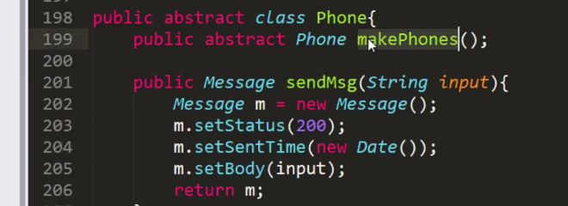

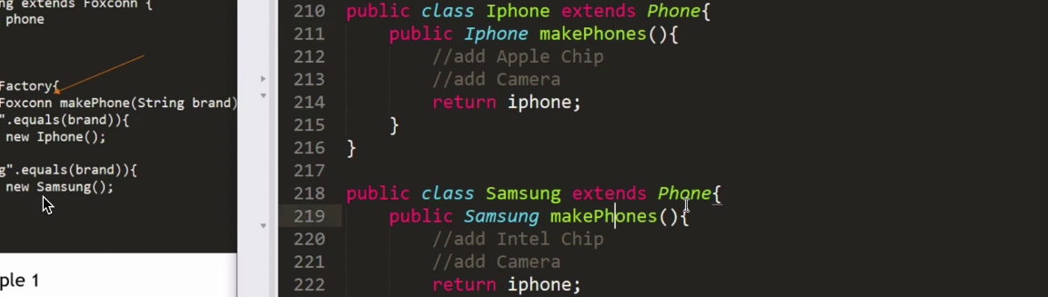

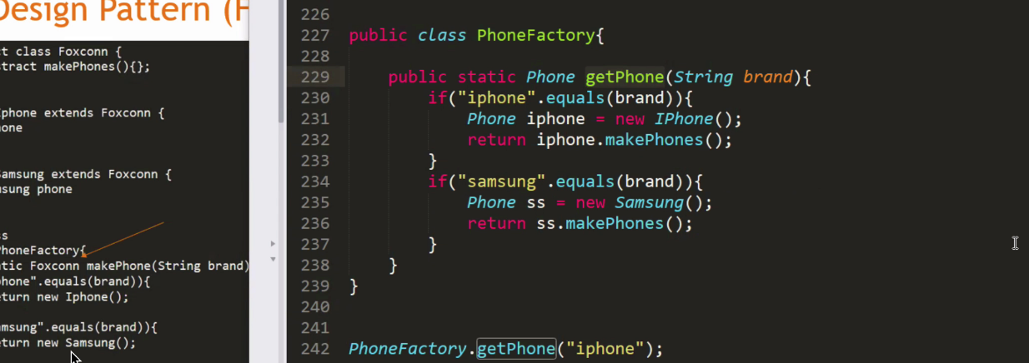

**What is the Observer design pattern?**

We have a new agency that can notify different channels when it receives news. When something changes in news, it will cause the channel to be notified. In the NewsAgency Class, we have field news, channels list, addObserver, setNews method. When the change happens on news( setNews() ), newAgency notifies the channels about the fact by calling the channel's update() method.

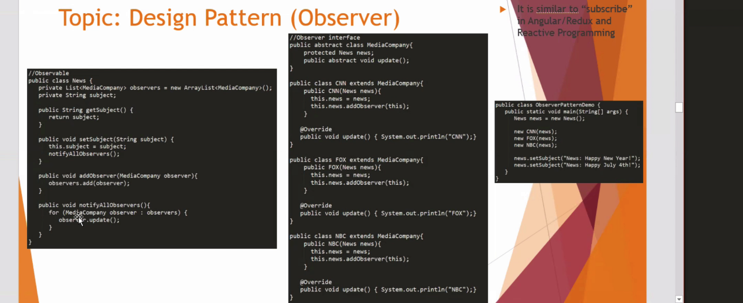

**Builder pattern?**

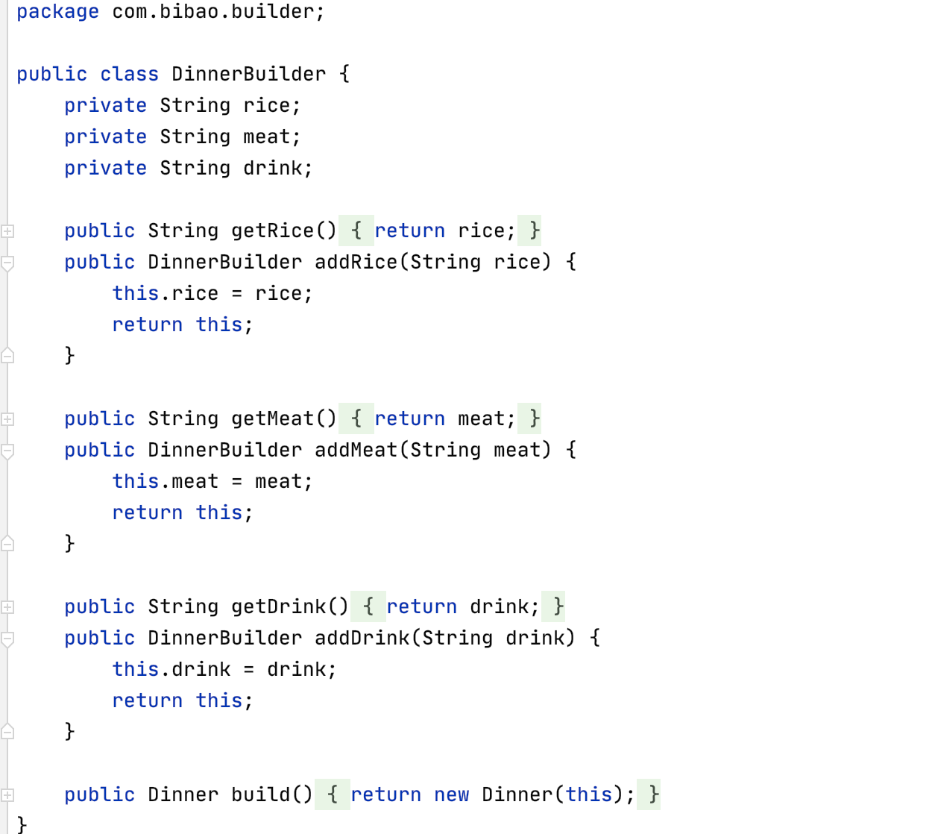

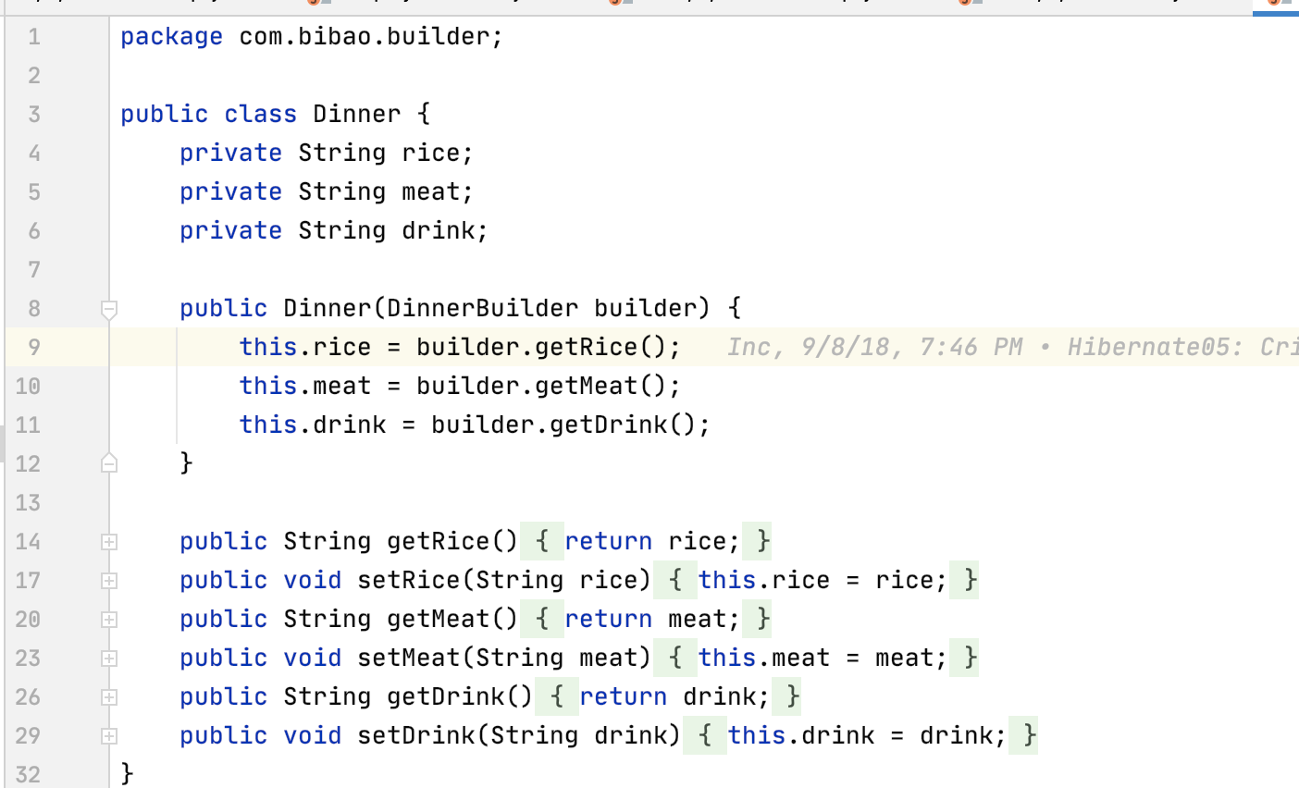

**List error in java?**

Stack will overflow.

Heap will be out of memory.

**What is a checked and unchecked exception?**

**Runtime exceptions are unchecked exceptions.** We need to fix it. IndexOutOfBound Exception, nullPointerException.

**Checked exception is the exception except runtime exceptions.**

We use try catch blocks or throw, throws keywords to deal with it. Like fileNotFound exception, sqlException.

***CORE JAVA 4:***

**What is the type of variable in the interface?**

It must be static and final. In the convention / generally, the shared variable used for the class implementing the interface should not be changed, so it should be static and final. So the shared variable is constant.

**When do we use abstract class instead of interface?**

When the abstract class has some concrete methods which will be used in the subclass which extend the abstract, we will use the abstract class, otherwise we will use the interface

Abstract class should only be extended by one class, interface can be implemented by multiple subclasses.

Abstract class field can be not static, interface must be static.

For multiple inheritance, we should use interfaces.

**How many kinds of collections do you already know?**

set, List, queue.

**What is a list?**

We can add elements to a list by index order. Get the element by the index. List allows duplicate elements.

**What is the difference between list and set?**

Set does not have an index, does not allow duplicate elements.

List has an index,it has the index order and allows duplicate elements.

Time complexity: insert, search, delete for list are all O(n),

insert, search, delete for set are all O(1)

**What is the difference between hashset and treeset?**

When we add a, b, c, three elements into a hashset, when we try to traverse the hashset, it will not return the elements by the a, b, c order.

But the treeset can sort the elements in the treeset.

**What is the difference between arraylist and vector?**

Arraylist is not thread safe, vector is thread safe, there is a lock provided to make sure only one thread can access the vector.

**Analyze the time complexity and space complexity of the operations in Arraylist(LinkedList)?**

逻辑：读取中间，读取末尾，插入中间，插入末尾。

**How does Hashmap work internally?**

Hashmap has a list of buckets inside which is an array. When we call map.get(key), hashmap will locate the bucket based on the hashcode of the key.

So we know the entries in that bucket, then the hashmap will call the equals() method to compare the key you want with the key inside the bucket. Finally return the value corresponding to the key. If we call map.put(key, value), it will locate the bucket and use the equals method to compare the key in the bucket. If duplicated, do update, if not duplicate insert it at the head of the Linkedlist in the bucket.

**What is the advantage of hash collision?**

Hash collision can reduce the space allocation.but if there is too much hash collision happening, it is possible that hashmap will be converted to linked list, which will reduce the access efficiency.

***CORE JAVA 5:***

**How to customize an object as a map key?**

We can put an object as the map key, but we need to override the hashcode and equals method in the object. So when we put the object as the key of the map, it will use the hashcode method in the object to choose which bucket the object put and use the equals method to choose which pair value to get when calling map.get(object).

**Java 8 new features:**

Map key can be null, but only one.

stream() API is used to process collections of objects. It provides stream.map(), filter(), sorted. forEach, collect, reduce. It can use one line code to finish multiple line tasks.

lambda(): () -> {}, if we want to new a comparator<>(){}, we need to override the compare method in the method block. But in lambda expressions, we can simplify the code like this.

( (a, b) -> {b - a})

1. **map:** The map method is used to returns a stream consisting of the results of applying the given function to the elements of this stream.  
   List number = Arrays.asList(2,3,4,5);  
   List square = number.stream().map(x->x*x).collect(Collectors.toList());
2. **filter:** The filter method is used to select elements as per the Predicate passed as argument.  
   List names = Arrays.asList("Reflection","Collection","Stream");  
   List result = names.stream().filter(s->s.startsWith("S")).collect(Collectors.toList());
3. **sorted:** The sorted method is used to sort the stream.  
   List names = Arrays.asList("Reflection","Collection","Stream");  
   List result = names.stream().sorted().collect(Collectors.toList());

**Java 8 new features?**

1. Default method in the interface is not an abstract method but a concrete method, so the child class implementing the interface does not need to override the default method. If Integrationone class implements multiple interfaces which have the same named default method, the class has to override the method.
2. What is the functional interface?

If an interface has only one abstract method, it can be called a functional interface. It has an annotation @functionalInterface. Because java8 has the new feature lambda which implements the functional interface, if there are more than one methods in the functional interface, lambda has no idea how to implement which one.

1. Static method which is not allowed override.
2. Lambda expression: forEach(), stream(), (p1, p2) -> (p1 - p2),
3. Optional keyword.

**What is the difference among hashmap, hashtable, and concurrent hashmap?**

Hashmap is not thread safe, but hashtable and concurrent hashmap are thread safe.

Hashmap can allow multiple threads to access it simultaneously.

Hashtable can allow only one thread to access it.

Concurrent hashmap can allow multiple sections to access it. Each section includes multiple threads. Each section is thread safe, once one section is available, the waiting thread can enter into the section.

**What is the exception occurring when multiple threads access one map?**

concurrentModificationException.

Map should convert the map to the entity array, which has an iterator to traverse it.

**How does Hashset work internally?**

The same as a hashmap, except that we can not access the value corresponding to the key.

**How to remove an element from a list efficiently?**

**If you want to remove one element from an arraylist, is it safe to use for loop? If not, what to use?**

Using a for loop to traverse the list and remove the element may result in concurrentModificationException.

Using list.iterator() to traverse and call remove method will be more efficient.

**How to create a thread?**

1. implement the runnable interface.

2. extends Thread class. Override the run method.

3. Implement callable interface and override call method.

4. Create a instance of the executor service and new a tread pool.

Thread a = new Thread(obj who implement runnable or extend thread class)

**Race condition:**

Multiple threads try to change the object status.

**What is the difference between run() and start() in a thread?**

run() will interrupt the current thread but start() will not and it will concurrently run with the other threads.

start() run the thread really, but run() not.

**What is the thread life cycle?**

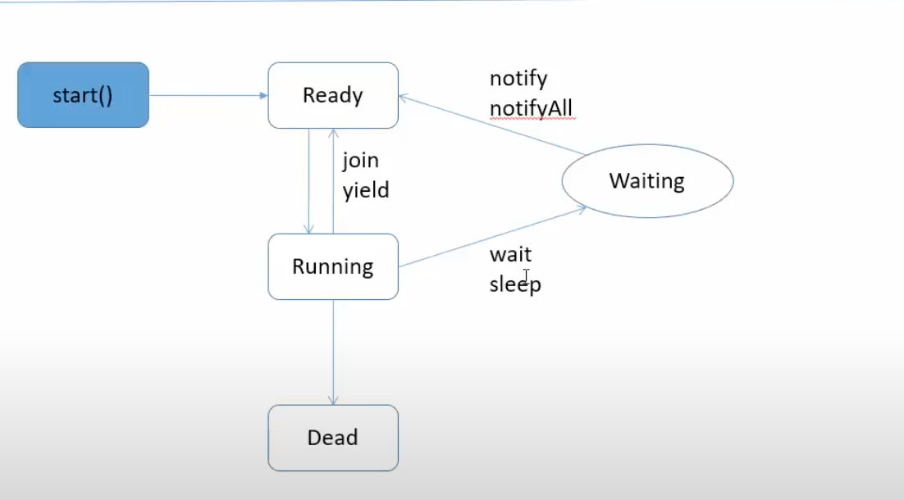

***CORE JAVA6:***

**What is the difference between the threadlocal and volatile?**

Threadlocal creates a thread level copy of the object.The Java ThreadLocal class enables you to create variables that can only be read and written by the same thread.

Volatile refers to all the thread shares and updates the same object. If there is any change of the volatile variables, the JVM will inform other threads the changes happen.

It's not thread safe if multiple threads are writing and reading the variable. It's thread safe if you have one writer thread and multiple reader threads.

**What does the join() mean?**

It means telling another thread to wait until this thread is completed or just wait for the given seconds.if the main thread runs the code like t1.join() means the main thread has to wait until the t1 thread finishes.

**Given three threads, how to let them run orderly?**

**Main{**

t1.start();

t1.join();

t2.start();

t2.join();

T3.start;

t3.join();

**}**

Tell the main thread to wait t1, t2, then t3.

main(){

t1.start(o);

t2.start(o);

t3.start(o);

}

T1{

// do some things

t2.notify()

}

T2{

wait()

t3.notify()

}

T3{

wait()

}

**What is the difference between synchronized keyword on method declaration and synchronized block?**

If the synchronized keyword is on the method declaration, it will lock the whole object, other methods which are not locked also can not be accessed.

synchronized (object) means it only locks the object.

Public static synchronized void test(){

}

Public static void test(Object o){

synchronized(o);

}

***CORE JAVA7:***

***What is the executor service?***

Executor service can create a thread pool that can run multiple threads at the same time to execute the task. Use invokeAll() to start all the threads, return a future type, use shutDown() to shut down manually.

newCachedThreadPool(size), newSingleThreadPool, newFixedThreadPool(size)

***List some methods in executor service?***

execute() : execute the task which does not need a return value.

submit(): execute the task which does need a return value.

invokeAny():

invokeAll(): return a list of futures by the order of the iterator traversing the thread pool.

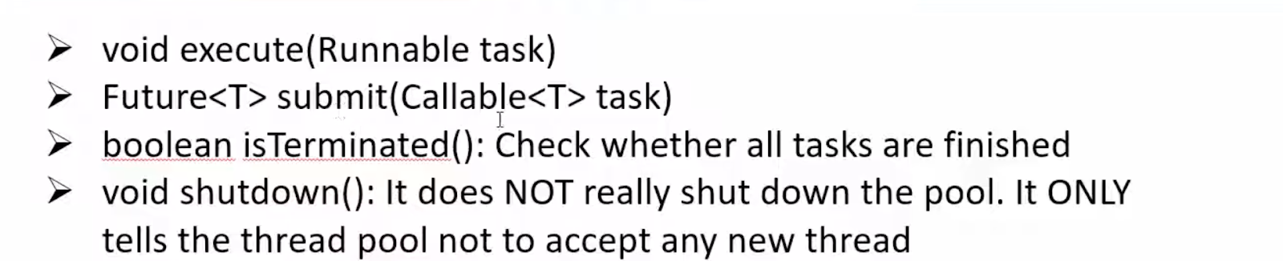

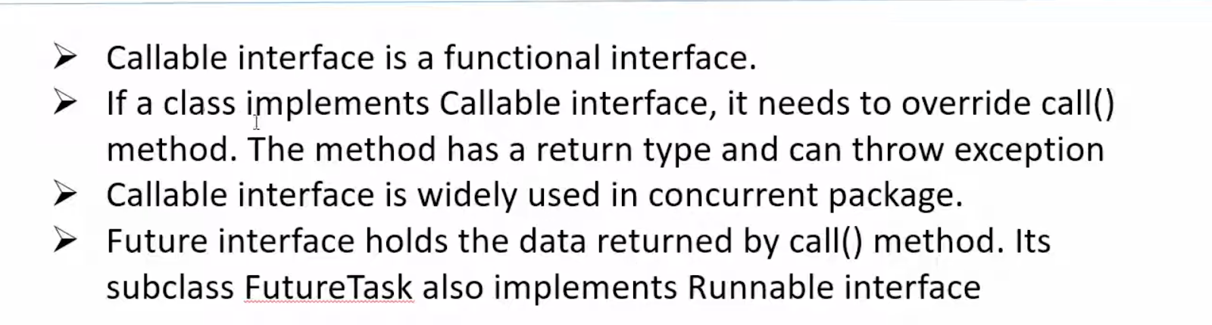

***Runnable vs callable?***

Runnable has no return value, which will be used on the execute method.

Callable can return Future Object which is used on the submit method. Future.get() can get the value in the future, future.isDone can check if the task is done. Future.cancel can stop the running thread.

Future is like an async method, when the data in the future object is not ready, other code can be executed first. After the data is ready, then return it to the future.

***The benefit of using lambda?***

To replace anonymous classes, avoid large blocks of code and return.

Given an ArrayList including all US states, Write a program to return all states starting with letter

“N”, for example, New Jersey, New York etc.

States result = states.stream().filter((s) -> “N”.equals(s.getName()[0]).findAny().orElse(null);

***The main method in java 8 stream()?***

list.stream().Map(p -> p.getName()).collect(Collections.toList()) (toSet, toArray(), toMap())

list.stream().filter(p -> p.getName().equals(“jack”)).findAny()/findFirst().orElse(null);

Sort, sorted, reduce().

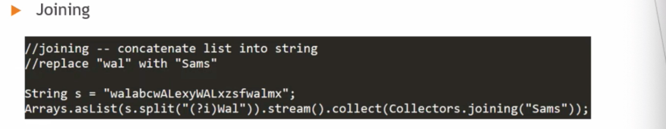

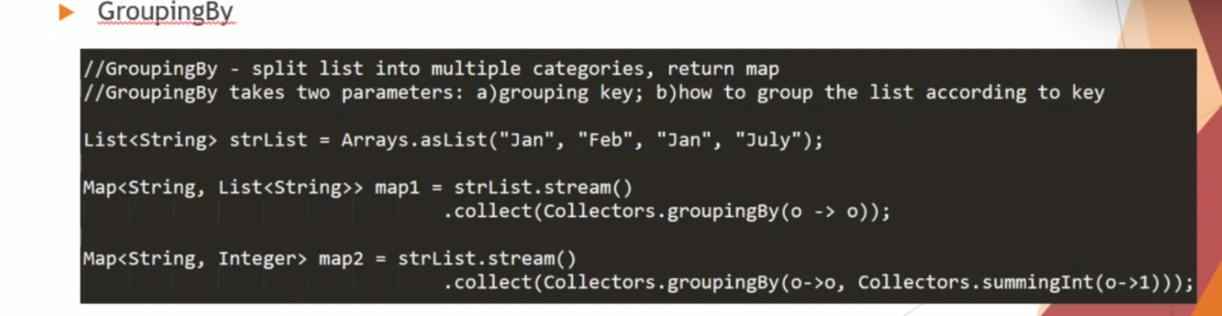

***The optional class?***

It is to avoid NullPointerException.

The commonly used method is get(), Empty(), isPresent(), ifPresent(), orElse()

***DATABASE 1***

***What is elastic search?***

It can add indexes for the data and cache the data for quick search. It is like between the java and database, it can only be used to search data.

***Difference types of join?***

Only join is inner join which only matches data that matches both tables at the same time.

The LEFT JOIN includes all records from the left side and matched rows from the right table.

RIGHT JOIN returns all rows from the right side and matched rows from the left table.

***Primary key vs unique key vs foreign key?***

Primary key must be unique, It should have the characteristics that represent the table. It can be a composite key.

a unique key is the key that doesn't repeat other than the primary key.

Foreign key is the key that is responsible for the connection with other table.

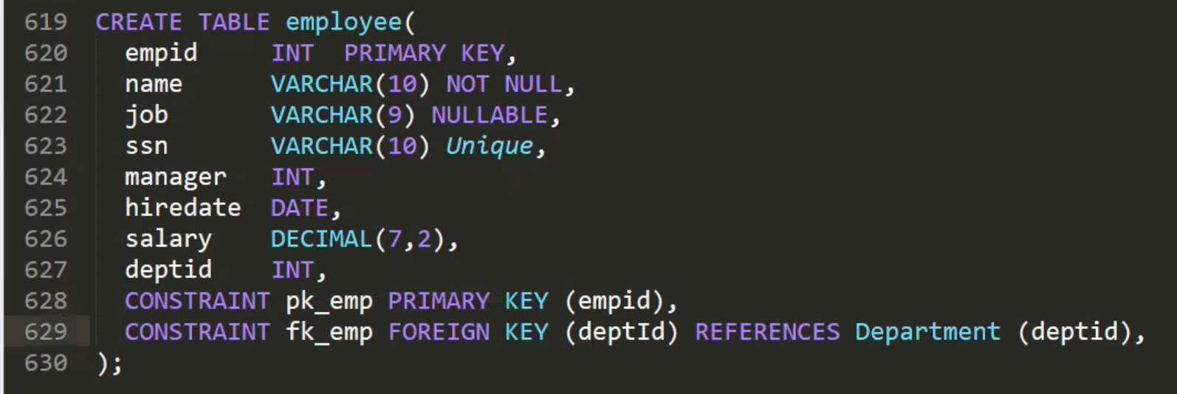

***Truncate vs delete vs drop?***

Truncate can delete the whole data in the table, and does not use the **where** keyword.

Delete can use the **where** keyword to delete a single data.

Drop is to delete the whole data and delete the table.

***View vs material view***

View does not save data, it is just a logic table.

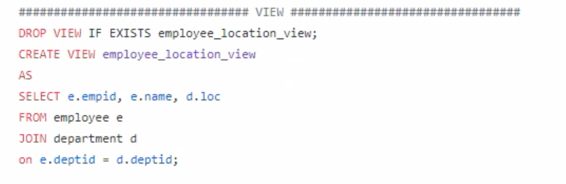

material view saves data. It can get data in advance. It can set time to run it.

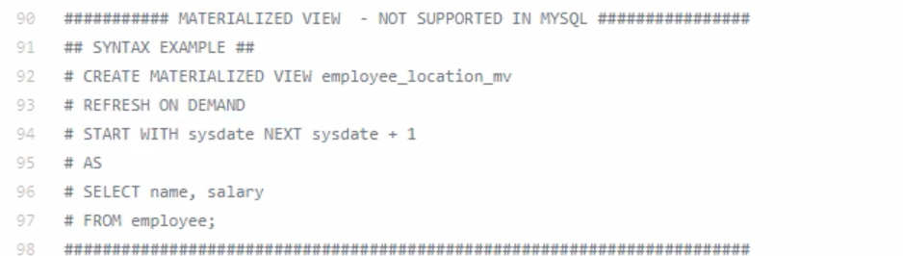

***DATABASE 2:***

***Clustered index vs Non-clustered index?***

Clustered index is only one index in the table which is sorted by the certain order. The data in the table will be sorted by the index order. So everytime we save new data in the table,we're going to adjust the index that we have already sorted and the index that comes after it. It will take more time. But when we want to search data by the index, it is more effective, because the index is sorted, we can use a binary search method to locate the index that we are looking for.

Non-clustered indexes have multiple indexes which are sorted by different certain orders. The original table’s order is not changed.

So the save or insert data operation just needs O(1) time, but needs more space to adjust the index in the non-clustered index.

One table has only one clustered index.

Non-clustered index can be multiple.

***Union vs Union all***

***1, 2 union 1, 2 = 1, 2 if union all : 1,2***

***3, 4 4, 5 3, 4, 1, 2***

***4,5 3, 4***

***4, 5***

***What is the stored procedure?***

It is a segment of sql logic which is stored in the database.

When we want to get a result based on the data in the database, this process needs multiple steps, and can not be completed with a SQL or simple SQL, we usually write this logic into the database, so that we can call it repeatedly. This logical SQL supports input and output.

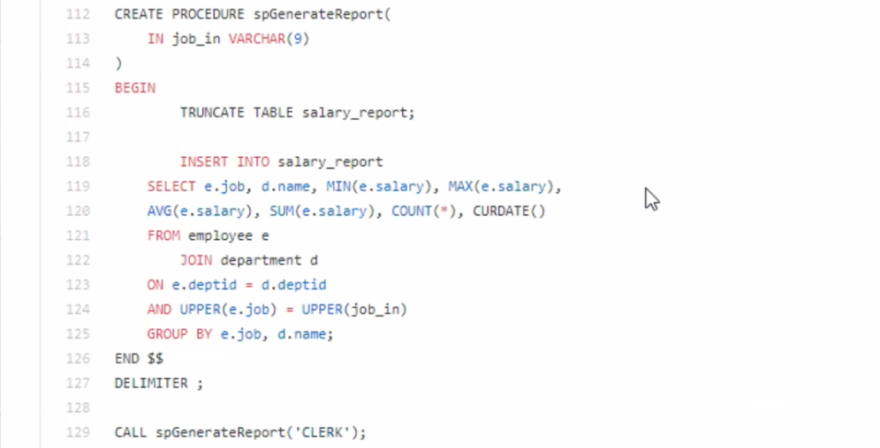

***What is JDBC?***

The only one way that java connects to the database. JDBC standardizes the way Java connects to databases.

***How to connect a database?***

4 elements needed to connect databases.

Database driver tells which database to connect to / how to connect .

URL tells where the database is installed.

Username and password also need to be configured.

***How to get data from a database by JDBC?***

Create a connection which uses the 4 elements above to connect databases.

Create a statement which is used to run sql.

Create a resultset which is used to save the parsed data returned from the database.

***What is the PreparedStatement?***

PreparedStatement is pre-compiled, it takes parameters. It can get the data in advance, but does not return it to the user, and then returns it after comparing it with the user's input. This can avoid SQL Injection.

How to avoid sql injection:

**A prepared statement “sanitizes” the input**. This means it makes sure that whatever the user enters is treated as a string literal in SQL and NOT as a part of the SQL query. It may also escape certain characters and detect/remove malicious code.

Data in the cache, so just replace the parameters and no need to submit the whole sql, so it is more efficiency.

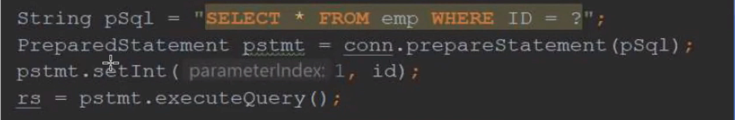

***What is the CallableStatement?***

It is for calling stored procedures.

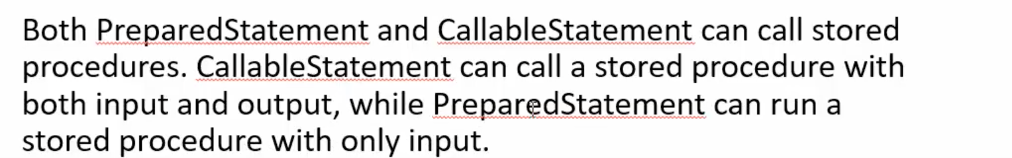

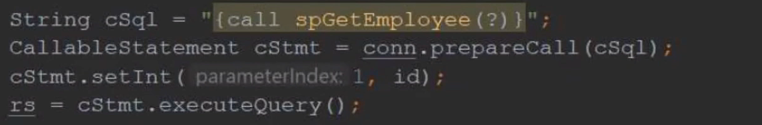

***RDBMS VS NoSQL?***

1. RDBMS: structure data(table based) NoSQL: unstructured data(document, column based) it is like a file system.
2. Transactions: it is like the process of saving money in the bank.

If I want to save 50 dollars in the bank and then withdraw 30 dollars. But if saving 50 dollars fails, then the withdrawal process will also fail, it is the whole process in one transaction.

RDBMS can support transactions, but most NoSQL does not support transactions.

1. Performance: RDBMS : LOW. NoSQL: High
2. Store medium to large data to RDBMS, Huge amount of data to NoSQL.

***SQL structure:***

select 查询列表

from 表1 别名 [连接类型]

join 表2 别名

on 连接条件 （相当于替换了之前的where）

[where 筛选条件]

[group by 分组]

[having 分组后筛选条件]

[order by 排序列表]

***MVC01:***

***22. Draw a diagram to show the data flow chain in enterprise project, your diagram show include: front end, database, dao, model, service, controller and security.***

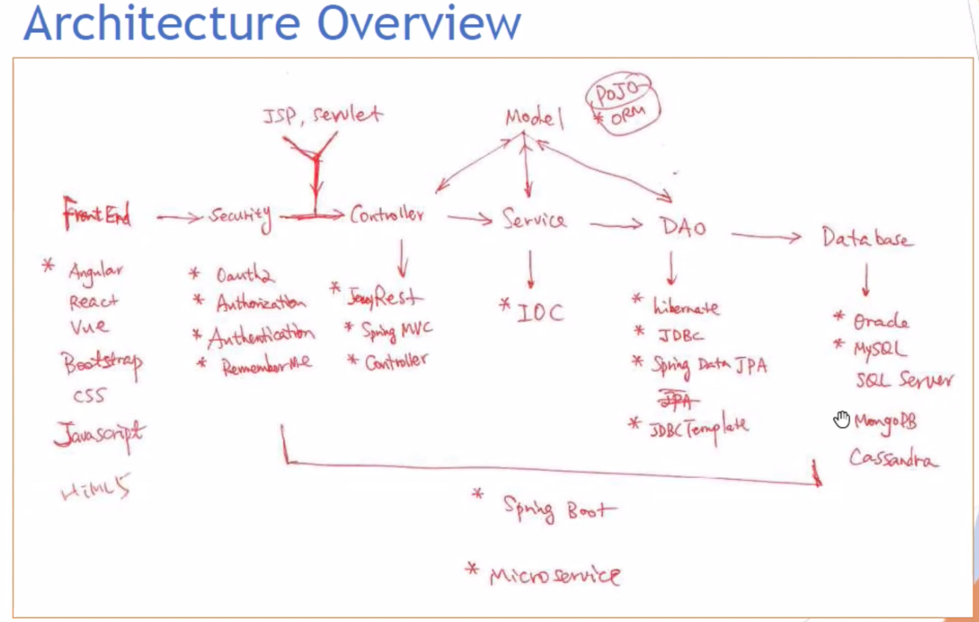

***What is a web service?***

Two types of web service:

SOAP: old thing.

REST: using get, post, put, delete, patch keywords to send the http request from frontend to backend according to HTTP protocol. It can transfer data using URL with path variable, query parameters or http request containing header and request body. The type of the data can be json, xml etc.

***What does the get, put, post, delete, patch mean?***

Get is to retrieve data from the backend.

Put is to replace. Delete means delete. Post is to add new data. Patch is to update part of the data.

***How to transfer data with rest api?***

1. Url: path variable, query parameter.
2. Request body: header, body(http request)
3. Response: header, body(http response)

***How to write a rest api?***

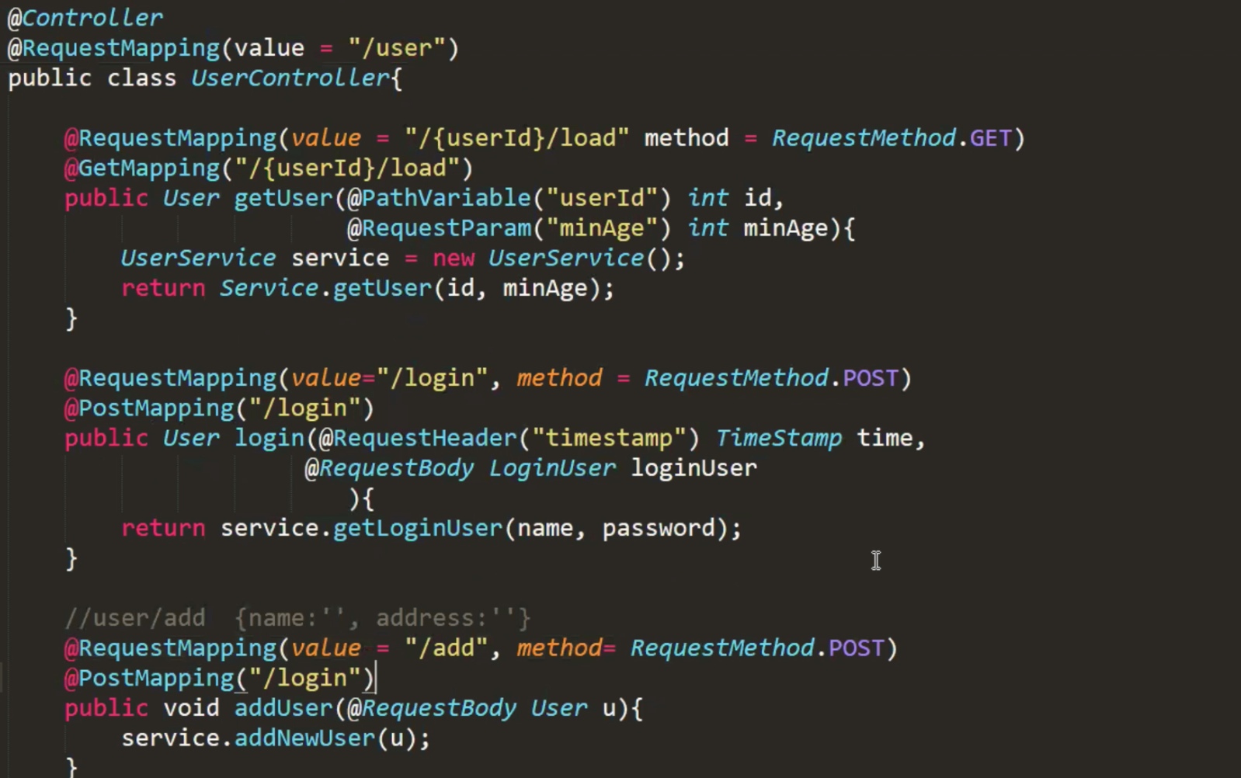

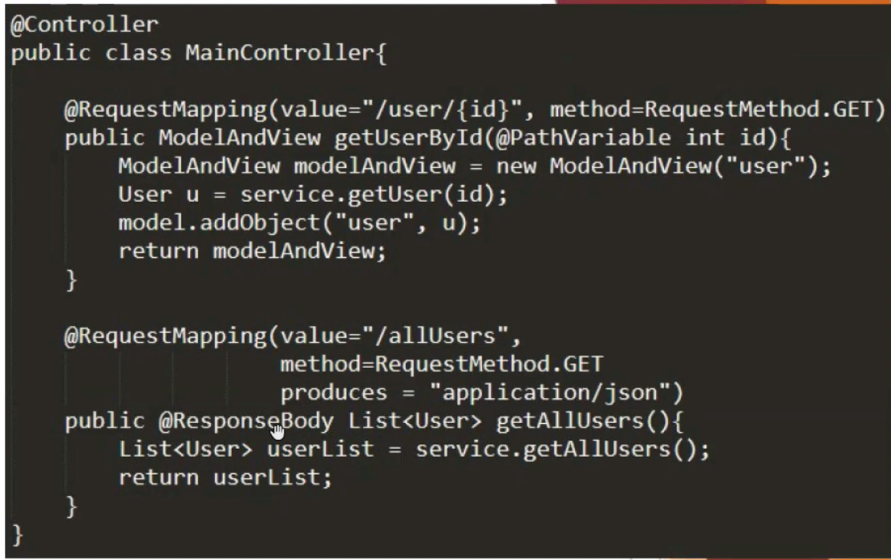

**What is the difference between controller and rest controller?**

@RestController = @Controller + @ResponseBody

restController returns data, but controller returns html or jsp.

***What is a cookie?***

It is a small space in the browser where things can be stored. The things it stored can be carried to the back-end server via a http request. If there is something needed every time the interaction between the front-end and back-end, it is a good idea to write it in the cookie. The most common thing in the cookie is the session id. The back-end server can verify that the session is expired to determine whether the request is secure.

Google definition:

Cookies are text files stored on the client computer and they are kept of use tracking purpose. Server script sends a set of cookies to the browser. For example name, age, or identification number etc. The browser stores this information on a local machine for future use.

When next time browser sends any request to the web server then it sends those cookies information to the server and server uses that information to identify the user.

***What is Session?***

A session creates a file in a temporary directory on the server where registered session variables and their values are stored. This data will be available to all pages on the site during that visit.

A session ends when the user closes the browser or after leaving the site, the server will terminate the session after a predetermined period of time, commonly 30 minutes duration.

***Session vs cookie?***

Cookie: front end storage, small size, can be used with http request.

Session: back end storage, has expiration time corresponding to the front end tab.

***What is the origin?***

Origin can tell the server where the request came from. If I want to send a request to google map to get some data, google map should verify if the request is authenticated, so google map uses the origin to verify.

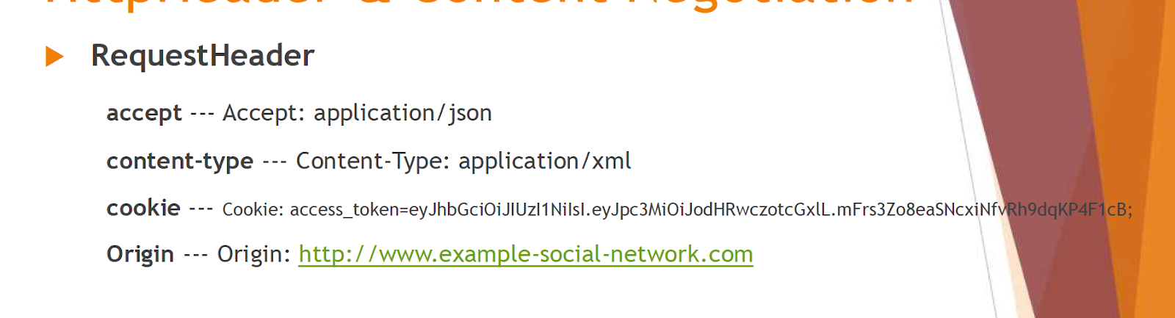

***Accept vs consumes vs produces?***

Consume is the content type back-end can receive from front-end, produces is to provide the content type from back-end to front-end, accept is the content type front-end can handle or receive from back-end.

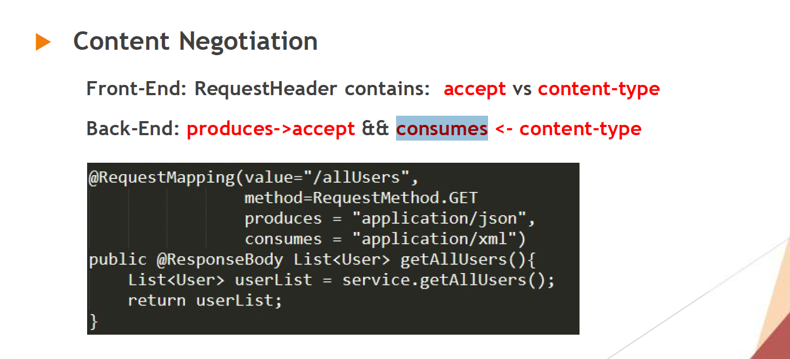

***Http Error code?***

Mapping is : user/id, if we get employee/user/a, the http error code is 404 which means we can not find the URL.

Mapping is : user/id, if we get /user/a, the http error code is 400 which means bad request because the a is not an integer.

Mapping is: user/1, if the url should be called by the administrator, but the calling is not then return 403, means not allowed.

Mapping is: user/1, you are the administrator but not login, then it will return 401, means not authentication.

Mapping is: user/1, the calling is ok, but when retrieving the data from databases, something wrong happens, it will return 501, means, internal server error.

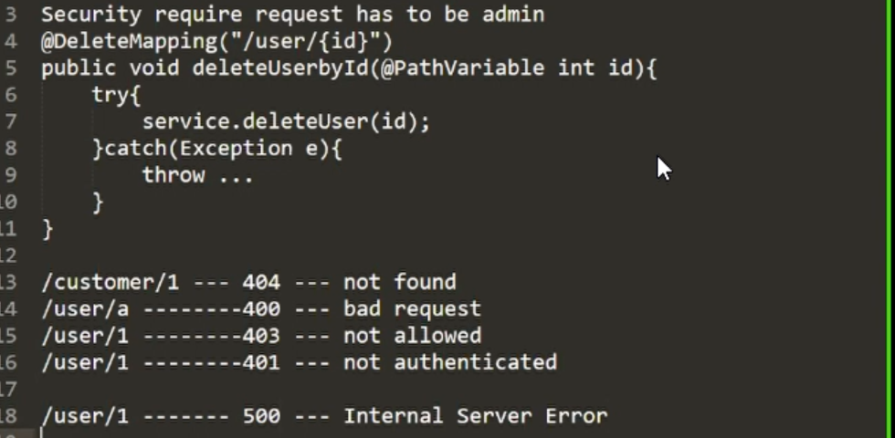

***What is dispatcher servlet and how does it work?***

The dispatcher servlet is like a control center which can handle the request from the front-end and responds back to the front end after processing the request.

It uses the Handler-Mapping to handle the request and map the corresponding controller based on the URL. Then the controller handles the request and returns the modelAndView. The dispatcher servlet extracts the view name and sends it to the view resolver to choose the corresponding view.

dispatcher servlet extracts the model and sends it to the view module to fill the view with the model then as a whole to respond to the front end.

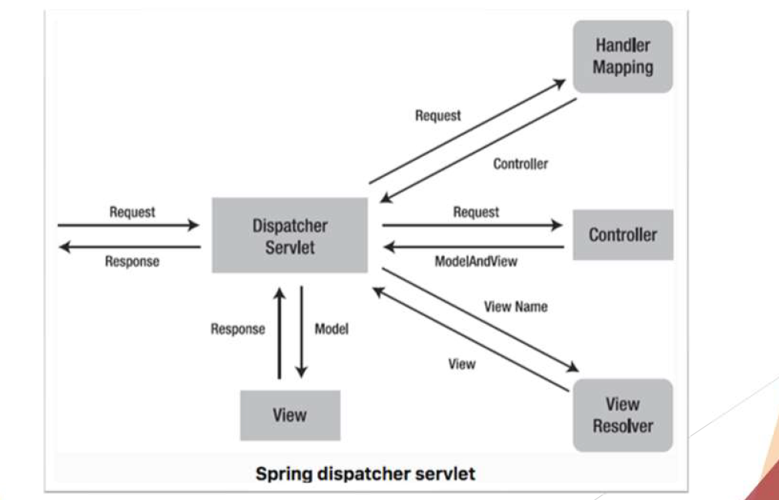

***What is CORS(Cross origin resource sharing)?***

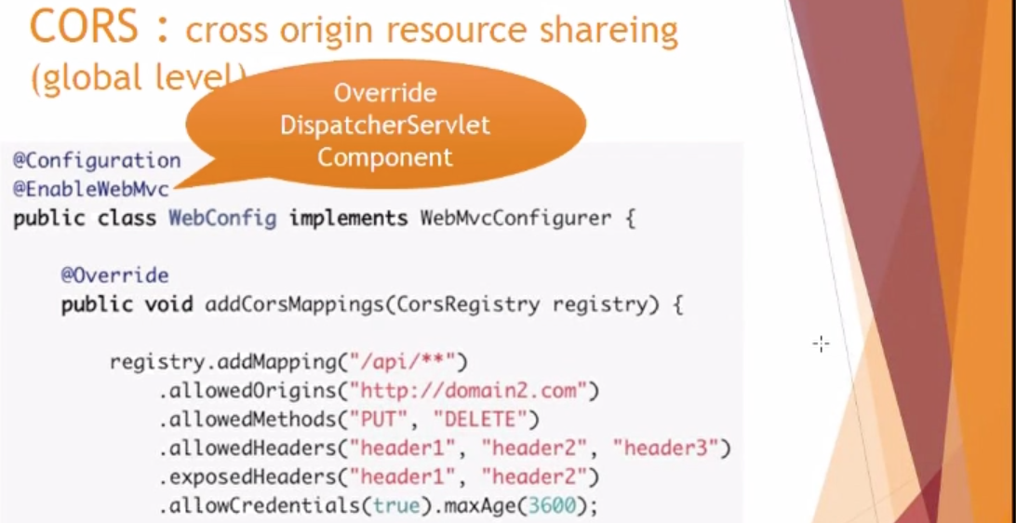

***What is the big challenge in your project experience?***

When I do an application in my resume, I try to use the spring boot framework to support my back-end, and use the react framework to support my front end. When I try to do some data interaction between front and back, it can not work because the two ends are not at the same domain, so how to send a request between different domains. I did some research on the website and talked to my professor, I knew it is a cross origin resource sharing problem. I did a demo application first to test if it can solve this problem, and after a few attempts, I solved the problem finally.

***What content does the httpHeader include?***

Accept type like(application/json), content-type(application/json, application/xml), cookie, origin.

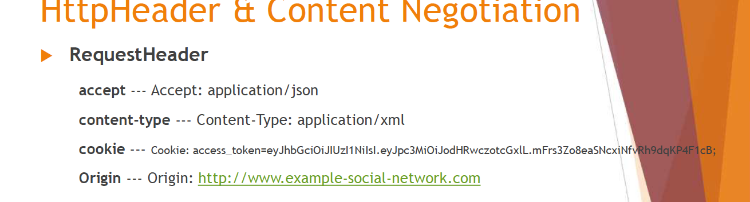

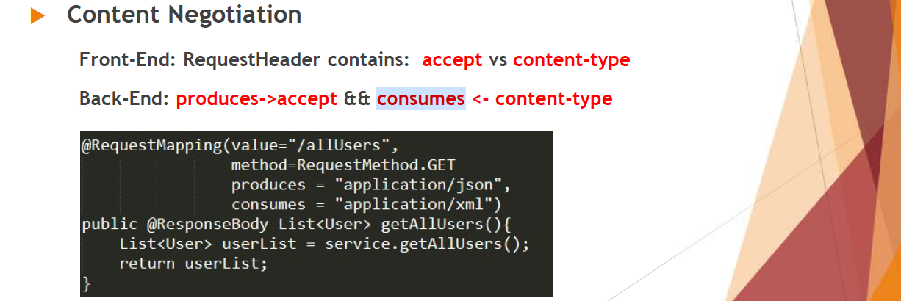

***Yml vs properties?***

Yml file has the format of the data. Like a tree.

Properties save the data line by line. Like a map.

***What is the Dependency Injection container?***

DI means that spring manages a bean factory, whenever you want some bean, just add @autowire annotation on the bean reference, the bean will be created by spring. The programmer tells the spring which bean is managed by spring using XML file or annotation, and injects the bean needed whenever it wants.

***applicationContext vs BeanFactory?***

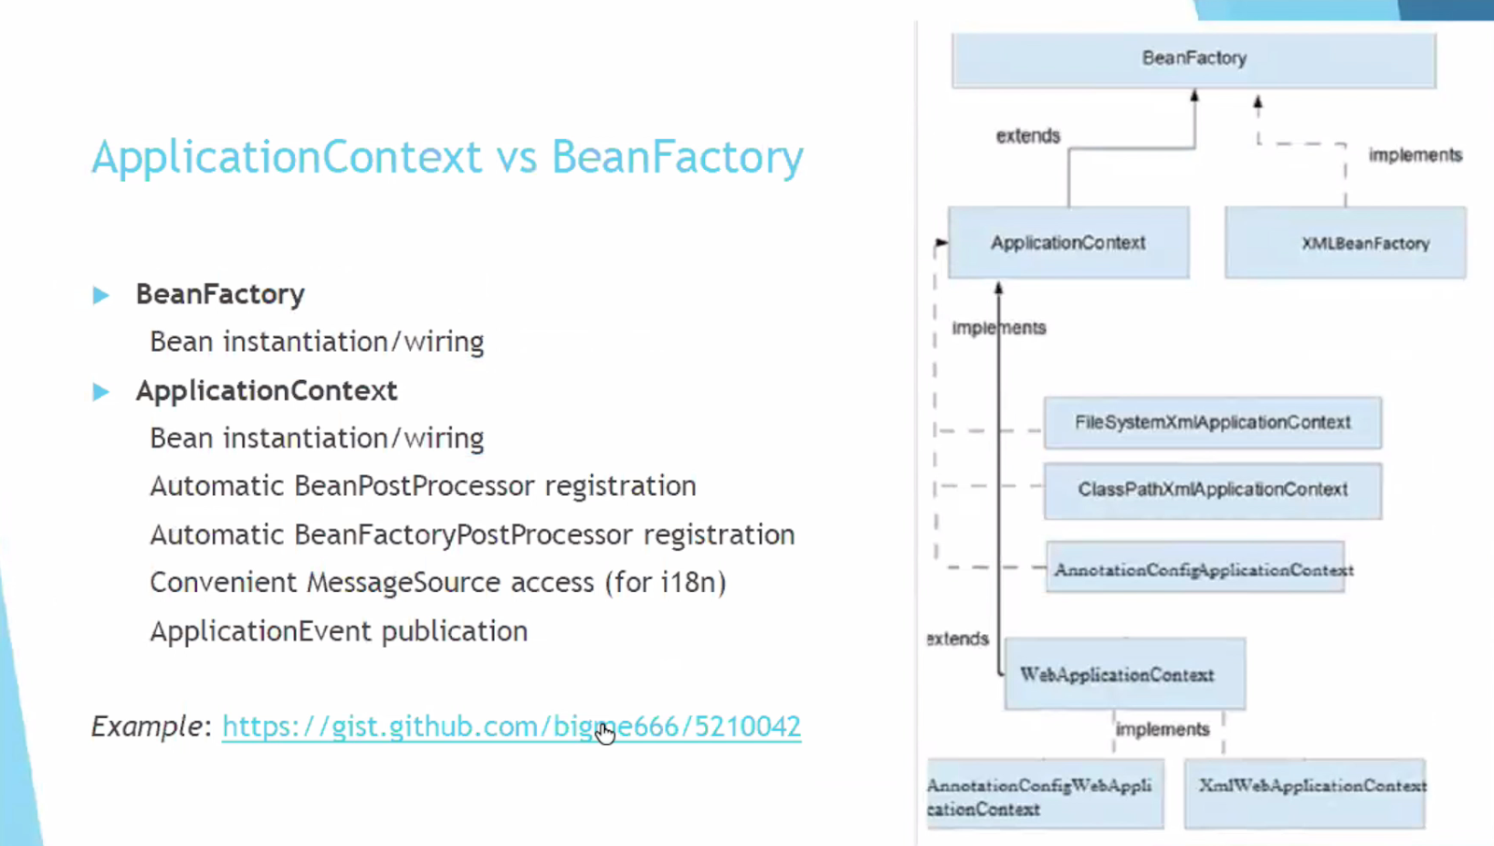

Both are container and interface. ApplicationContext extends from BeanFactory. They are all responsible for managing beans. Like bean instantiation or wiring.

But applicationContext has more features, like executing logic before or after the newly bean instantiation. It is easy for developers to handle messages from different locals, like for different languages, convenient messagesource access for internationalization(i18n).

Besides, it also easy to publish the application even to anyone who’s listening.

***The type of Dependency injection?***

***Construction-based:***

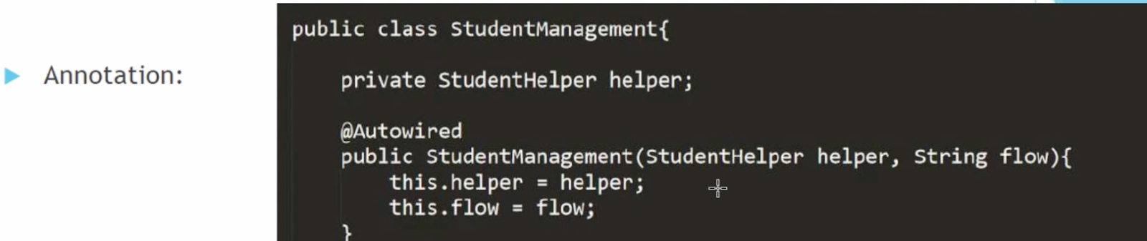

***Setter-based:***

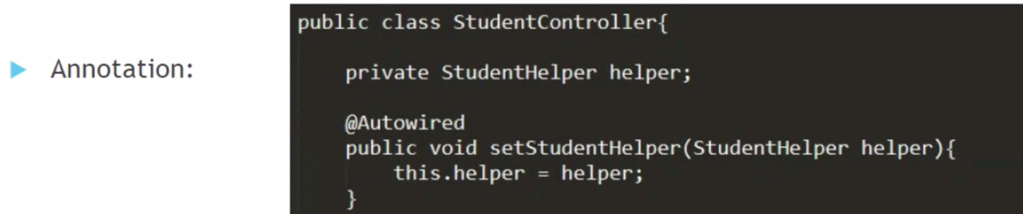

***Field-based:***

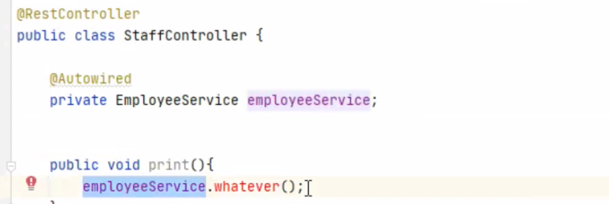

***What is the difference between constructor-based and setter-based injection?***

Constructor-based: when the class of the constructor instantiated, it is invoked.

Setter-based: when using the instance needed to set it will be invoked.

***What is the circular dependency?***

It happens when using the constructor-based injection.

Class1’s constructor needs the injection of the class2’s constructor injection. In the same way, Class2’s constructor needs the injection of the class1’s constructor injection. It will create circular dependency, and throw beanCurrentlyIncreationException.

***@autowire vs @qualifier?***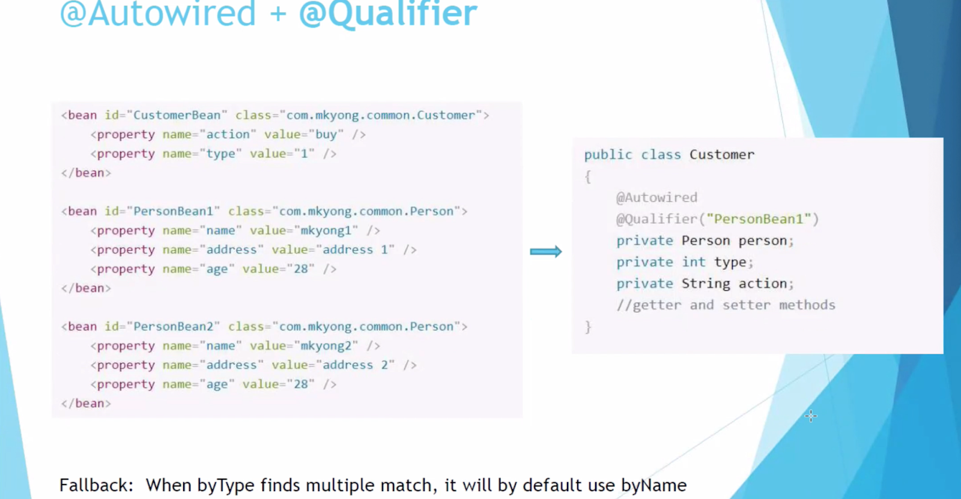

***What is the transaction?***

Transaction is from the service layer through the data access layer to the database

***What is the JDBC?***

JDBC is a connection that gets the data from the database, saves the data in the result set, running SQL to retrieve the data from the result set and put them to the corresponding field in the POJO.

***What is the Spring JDBC?***

It provides the template which can help us reduce the code when connecting to the database. When connecting to the database, we should do some repeated code, like open a connection, prepare and execute the statement, set up a loop to iterate through the result set, process the exception, handle the transaction, and close the connection, statement, and resultset. As a programmer, we just need to define the parameters of the connection, write the sql, do the iteration.

<https://www.baeldung.com/spring-jdbc-jdbctemplate>

***What is the Hibernate?***

POJO(which is decorated as an Entity by ORM) exchange the data from the database using ORM which is the object relational mapping, pojo’s field should have the corresponding column in the table in the database. Hibernate uses HQL, criteria and sessions to operate ORM to get data from the database.

***What is the difference between POJO and Entity?***

Entity is POJO which adds an annotation on it.

***What annotation do you ever use when doing the entity mapping?***

@Entity, @id, @Table, @Column.

***How to make a composite primary key in the entity mapping?***

Using @EmbededId annotation on the composite id declaration in the entity class, and adding the @Embeddable annotation on the composite id class. For example: employeeId = employee Name + companyId.

***One to many relationships, many to one relationships?***

One person has many bank accounts, many bank accounts correspond to one person. Add @ManyToOne annotation on the many side, and add @OneToMany(mappedBy = “many side field” ) annotation on the one side

***how to do a many to one relationship in Hibernate ?***

Many visitors can visit one house.

House(hid, address), visitor(vid, name, hid as fk)

many side control the one side. many know one side, but one side does not know the many side. when the cascadetype is all, doing the delete operation will have some problem, because the some other related dependencies will be deleted then affect other data. fetch type is lazy means the dependency entity will only be accessed when getting the details of it. it is a lazy fashion.

***how to do a one to many relationship in hibernate?***

house(hid, address, visitors)

visitor(vid, name, hid)

We usually do it with bi-directional method. House entity should have the @onetomany annotation and @joincolumn annotation. Visitor entity has the @manytoone annotation. But when one side wants to save the many side, many side should match the foreign key in the many side with the primary key in the one side. So we should add the mappedby=“house” in the @onetomany annotation to let the many side control the relation.

***Many to many relationships?***

one person has many addresses, one address can correspond to many people. Create a middle table named person_address (下划线underline)between the person and address, person table map to the middle table and the middle table map to the address table.

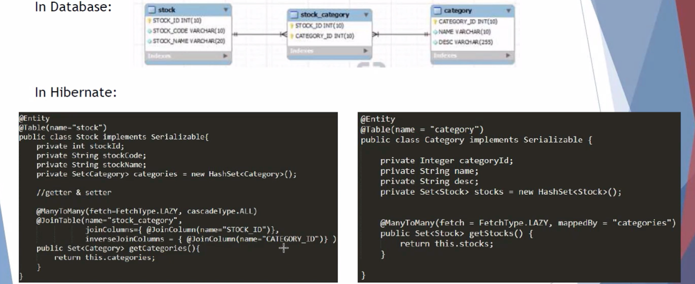

***What does the cascade = cascadeType.ALL mean?***

When we use all the methods provided by Hibernate, Its data will be synchronized with the database. (many-to-one, one-to-many)

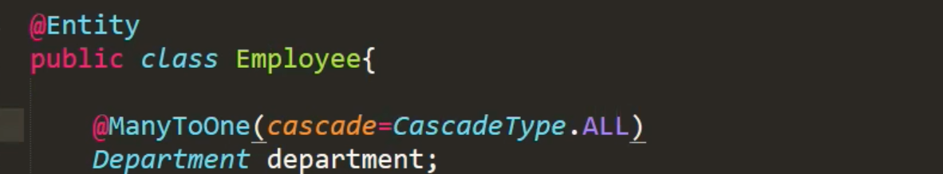

When save(), update(), persist() operate on the employee, the department field will synchronized with the database at the same time

***What does the fetch = fetchType.Lazy and fetch = fetchType.Eager mean?***

**Lazy**: fetching the data only when it is actually needed. Only load parent object, not with children.

**Eager**: fetching the data once the method is called. Load all of them.

***What is the difference between load() and get() in hibernate?***

get() loads real data, load() loads proxy.

load() == null ? exception.

get() == null ? null.

***What is the session in hibernate?***

Session is a common interface and a way of communication between java application and Hibernate ORM that can have one or many transactions. Session provides the methods like persist(), save(), merge() to operate the database.

***What is the caching in hibernate?***

Two level cache:

1. Session level cache, it can only be used by the session that has the cache. If I retrieve data from the database, the session level cache will hold the data in the cache, next time we retrieve the same data, the cache will give us no need to retrieve from the database.

(first level, minimize database visit, default, cannot be closed)

1. Session factory level cache, it is like a big bucket has some different sessions, all the sessions in the bucket can get the data from the session factory level cache, its purpose is for different session use. Using ehcache to configure the session factory level cache.

(second level, for cross session use, can be configured in xml/annotation)

***What is hibernate query cache?***

Query cache stores the query result and no need to visit the db again and again to execute the same query.

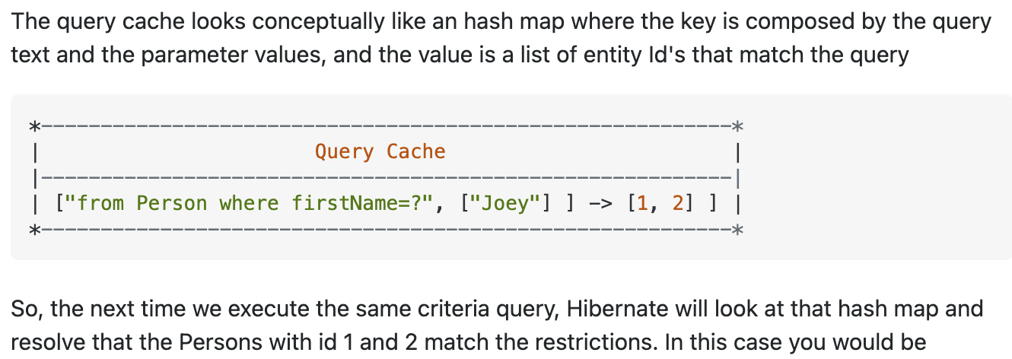

***What is the JPA?***

It is more like the hibernate but using the repository to manage the ORM not HQL, criteria, and session in hibernate. JPA eliminate SQL in java, using Naming convention in java method.

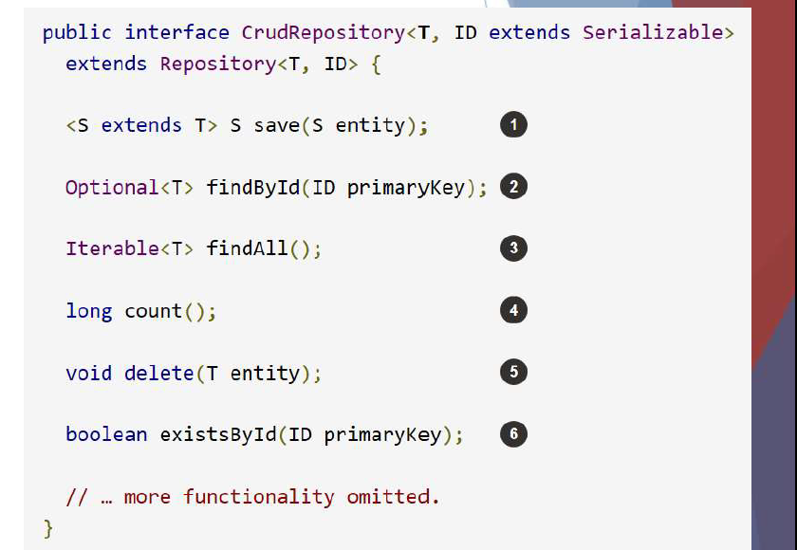

***What is the difference between JPArepository and CRUDrepository?***

JpaRepository returns a list. JpaRepository has all the features in the CRUDrepository and pageandsorting feature.

CRUDrepository extends the repository interface and returns iterable.

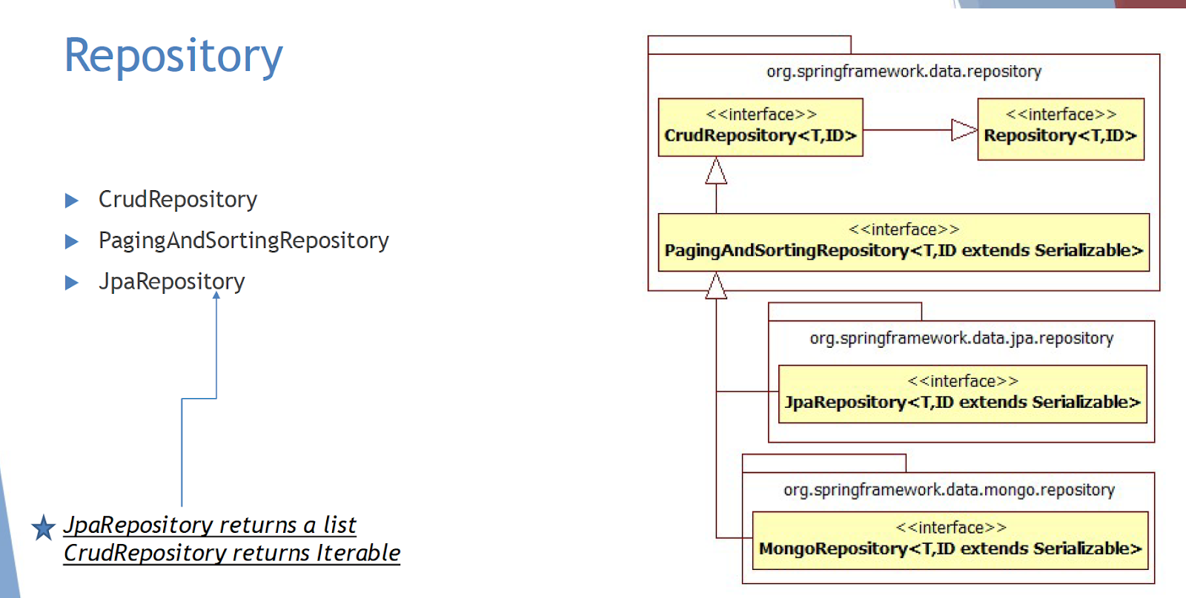

***What is the naming convention?***

JPA uses a naming convention to generate the sql automatically.

Like, findByName(string name) can be converted to select ** from table where name = “name”.

***If the amount of data transferred to the back-end from front-end is huge, how to solve this challenge to ensure better performance?***

Batch handling:

1. Database partitions can handle different parts of the data from different databases. Like the first database save the data was created 5years ago, the second one save the data was created 3 years ago, and the third one save that was created 1year ago. It is easy to get the data you want.
2. pagingAndSorting can handle different batches of data from the database to java.
3. Reduce the request time from front-end to back-end:

Caching the page you have been accessing.

***How to verify if the cache has expired?***

1. Set a timestamp in the cache, if the timestamp in the database is newer than the timestamp in the cache, update the cache.
2. A Version id will be updated to a new one in the database, so if the cache finds the version id does not match with the one in the database, update the cache.

***@query?***

When the JPA can not generate some complex SQL, using @Query annotation with a sql to run a native sql.

***What is transaction management?***

Like there are two actions in one transaction, if the second action fails, the first action should also be rolled back.

***What is the attribute propagation, isolation, rollbackFor, norollbackFor in @transactional annotation?***

Propagation: it means if needs transaction, required means need transaction, required_new means you can not use the rest of the existing transaction, you have to use a new transaction.

Isolation: read uncommitted means the people with the read uncommitted level isolation can read the data that is still not committed.

Read committed means the people with the read committed level isolation can only read the data that is already committed.

Phantom reads: it happens when isolation is read uncommitted,when the A, B, C will be committed one by one, before the C is written, A B can be read, after C something wrong happens, the transaction rollback A, B, C, so A, B can not be read like a phantom so it is called phantom read.

rollbackFor is for some specific exceptions to rollback.

norollbackFor is for some specific exceptions not to roll back.

***Work environment?***

Local -> Dev(push the code the server of the company, then we can do some test there) -> QA(the code that passed the test at the local environment, and then package and deploy it to the specific server of the company, in the QA environment, the test team also can use that) -> pre-Prod(copy the data of the real production environment test the app, test the performance of th app with the overloaded request) -> PROD(real environment)

***The process of the application development?***

***Agile development methodology:***

***Sprint: each sprint lasts 2-3 weeks.***

1. Planning: meeting with Programmer, QA(tester), business team(for requirement), scrum master(the spring principal) to determine the tickets and ticket points depending on how easy the ticket is, what priority of the ticket.
2. Grooming: meeting only the programmers, tech lead, architect participate without the business team and QA to clear the tickets and assign tasks.
3. Daily stand up meeting: Stand up every morning and report back on your progress.
4. Retrospect: review and summary the work you did in the sprint.

***Team organization:***

Project owner, QA, Business, Dev.

***What is JIRA?***

The todo List for the project task distributed on the jira website.

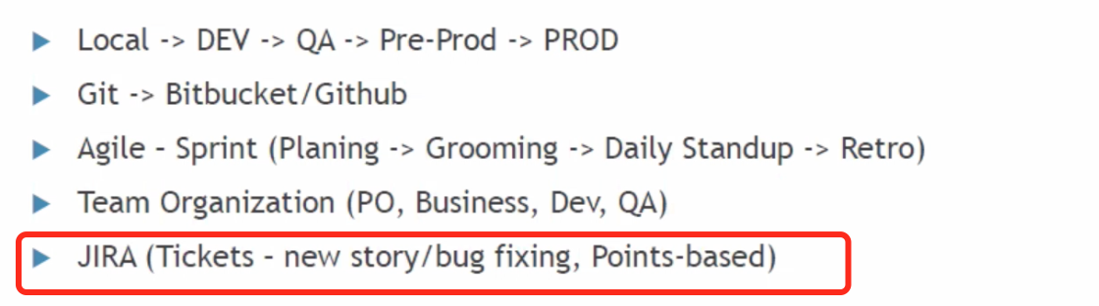

***What is the CICD(continuous integration continuous deployment)?***

The process that Packages the java code, deploys it to the server, run the test case in the QA environment, if fails deploy the original one and take off the wrong one, make the process automatically.

***How to implement CICD?***

Jenkins pipeline is always listening to the github, when there is some update in the github, jenkins will know it and run the pipeline script so that we have the automatic CICD.

***What is the pipeline script?***

It includes three stages which have their own steps. Like the build stage needs to package the java code, deploy stage just deploy the jar package to the server, test stage has the step run the corresponding test case. It also includes a POST in which the script will run when the test is successful or failed.

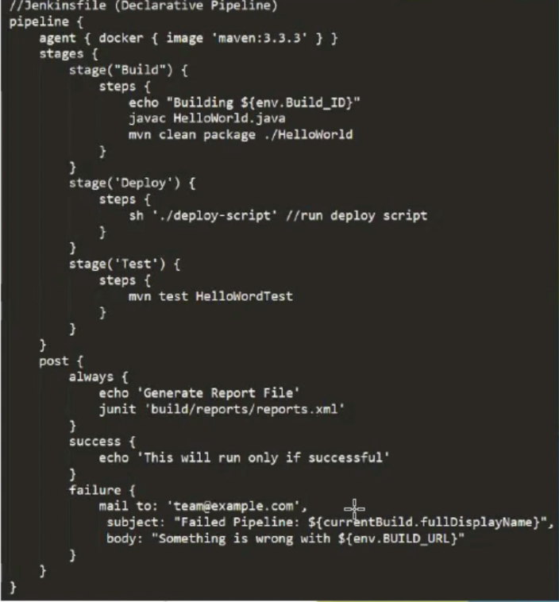

***Test type in industry?***

Peer test: test by your teammate.

Unit test: test for one method.

Functional test/application test: project owner test from the UI.

Integration test: test the dependency between different modules

Regression test: test compatibility between different versions.

***What is the automatic test?***

It is just a script to run all the test cases automatically every time needed.

***The tools corresponding to the different tests?***

Selenium is for automatic filling out the form on the website.

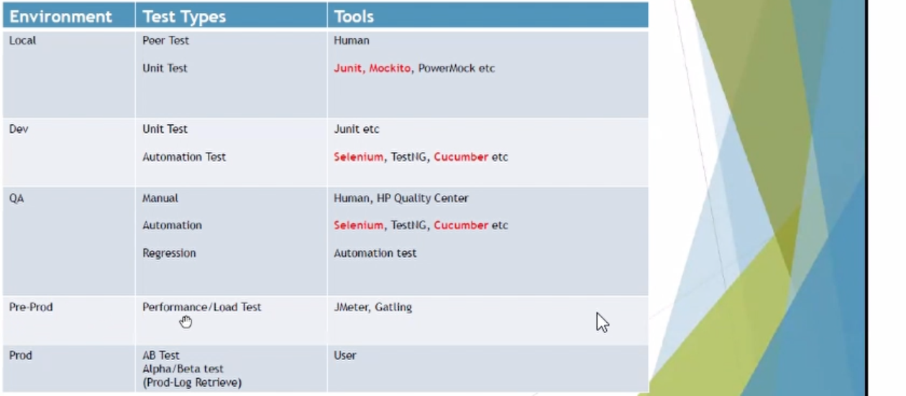

***What is the Cucumber?***

***Using some key words for the business requirement use, like Given When Then.***

***In the test case, programmers can use the @Given @when, @then annotation to convert the business requirement to test case.***

***Cucumber corresponds to behavior-driven development.***

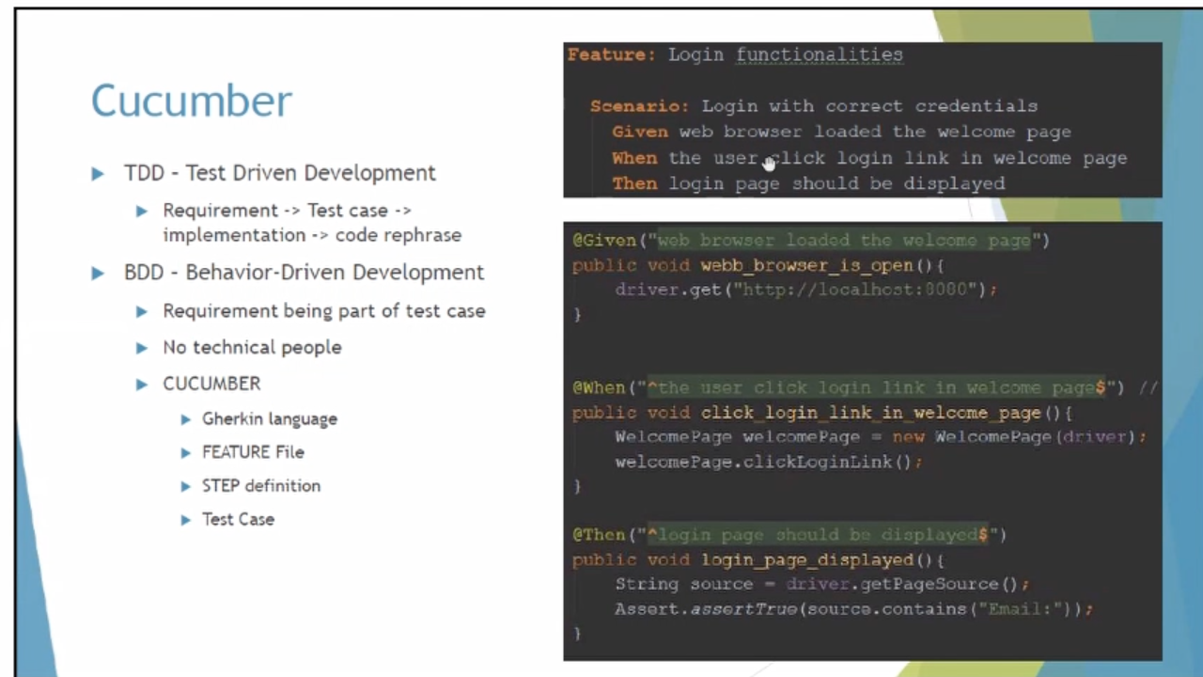

***What is micro-service?***

The micro service can break the huge application into small pieces of services, each can work independently and they can communicate with each other by http request. cloud is enabled to dynamically scale hundreds of microservices. Like in the distributed system, there are many instances which hold their own request coming to the service layer, so how to allocate these request to the right service, the cloud technology can solve it. All the requests are sent to the cloud, cloud allocate them to the correct service and balance service load.

Each spring rest service is the micro-service.

***What is the advantage and disadvantage of micro-service?***

Advantage:

Each miro-service is independent, so if one of them goes down, others can work well.

It is easy to add new features and new technology in it, easy to debug and automatic test. Like different services use different coding languages and frameworks.

Disadvantage:

Different services are on the different servers, needing more costs.

Different services need more staff to develop and maintain so that costs more.

Communication efficiency between different services may be slower than that on the same server.

The transferred data needs to be synchronized.

***What is Eureka?***

Eureka is responsible to register different services, if one of the service servers registered in eureka goes down, eureka can change it to another free server and update the server that went down, after updating, move the service back to the updated server. So the user will not be affected when the server goes down. It also can check the health status of the services registered in the eureka.

***What is the hystrix circuit breaker?***

When the service 1 sends request to service 2, service 2 goes down, generally the service 1 will have some problem because the data of the service 2 will be back to service1, in order to avoid this kind of problem, using hystrix circuit breaker to config on the service 1, when this kind of condition happening, the request sending to the service 2 from service 1 will be like a circuit back to the service instead affecting by the service2.

***What is the load balance?***

Ribbon can do the load balance.

When one of the services needs to accept most of the requests, the service will be overloaded then affect the performance of the system. Load balance technology comes in. it makes a certain number of copies of the service that accepts most requests based on the algorithm in the load balance. Allocate the requests to the different copies, so that the performance will be improved.

***What is the zuul gateway?***

It is like a distributor, all the requests come to the zuul gateway that is responsible to distribute these requests to which application. Amazon has 4 microservices, 1, 2, 3, 4. The four services are on different servers. What the zuul gateway does is like access <http://amazon/s1> means to access the service1, the rest can be done in the same manner.

***How do the two services communicate with each other?***

Direct access using restTemplate which is synchronized access.

messageQ: service 1 send a message to service 2, service 2 just read the message. Service1 does not care about Whenever service2 reads the message, that's service2's job, service1 doesn't have to wait for service2 to respond, and goes on doing its business.

***What is kafka?***

Kafka has a cluster or broker, it can be always running on a server. It has different topics in the cluster, each topic has several partitions to handle different messages or events corresponding to the message id. Like we have a service that looks like a producer to push a message or event to the kafka cluster, the message includes Topic, id, and a body. Another service is for the consumer to pull the message from kafka. The kafka is passive. This model is called the pull model, if kafka is positive to push a message to inform consumers, it is a push model.

***What if the consumers in the consumer group are more than the partition in the kafka cluster?***

The same copied consumer in the consumer group should not handle the same partition but if the consumer is not in the same consumer group can.

***How does kafka order the message sent to?***

Make sure the massage with the same topic and id goes to the same partition.

***What if the message buffer is full and the system goes down?***

Using blocking queue to replace the kafka queue, so that if the message is too many, they will not enter the queue to result in out of memory until the blocking has space.

***What is a Message Queue?***

It can provide the Async communication between the two rest services. It includes RabbitMq, ActiveMQ, kafka, camel, rocketMQ.

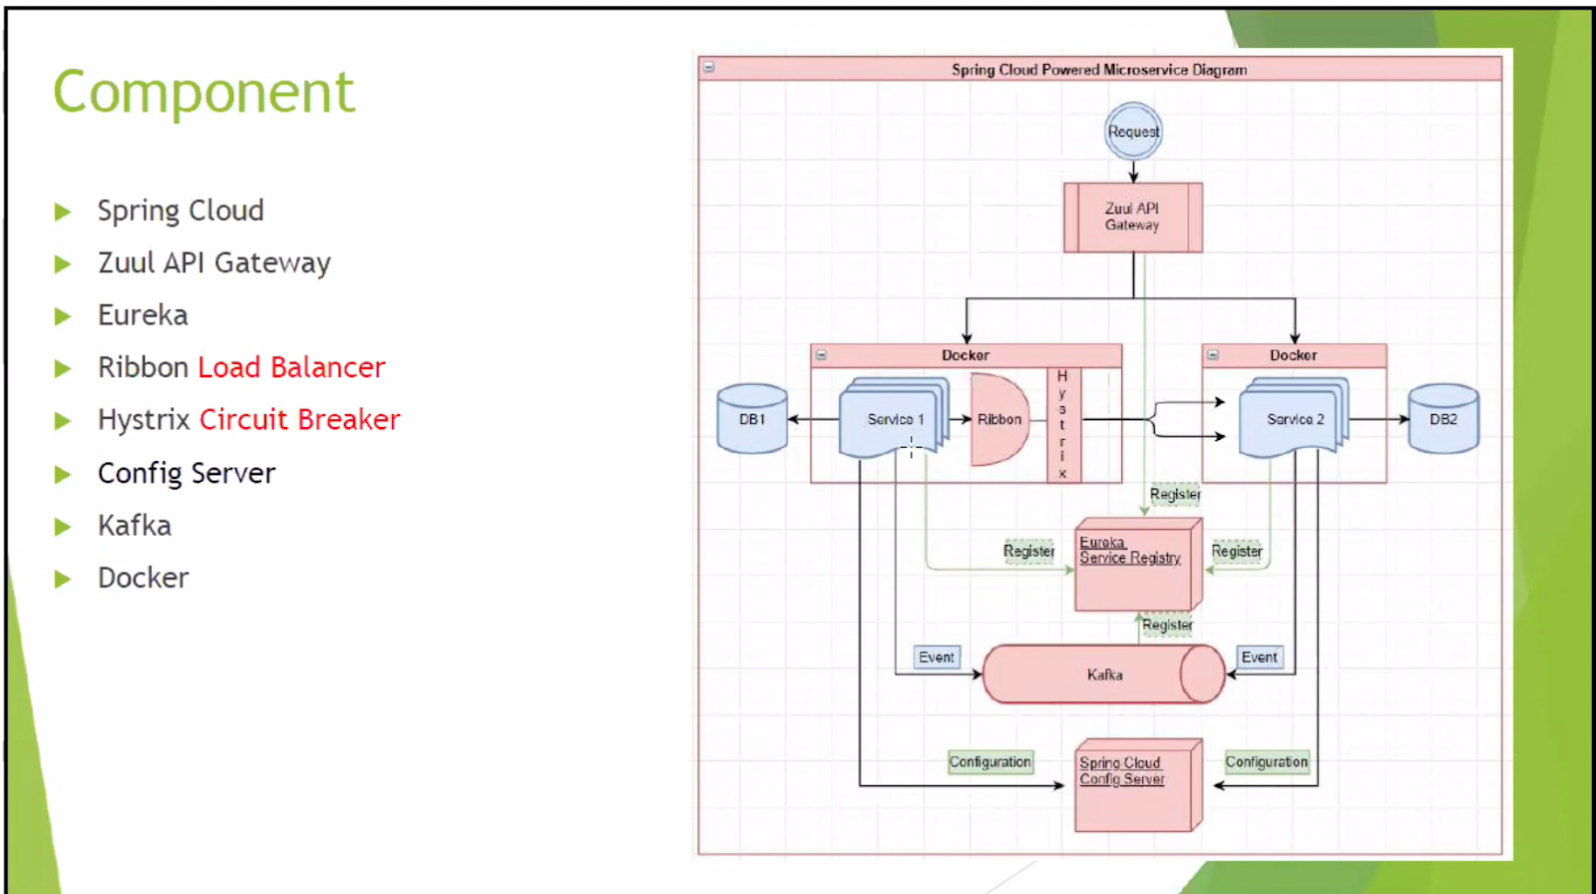

***SPRING FRAMEWORK 1:***

***Spring :***

***What is spring?***

IoC: inversion of control, the process of new one object, put one object to garbage collection is in spring charge not programmer. Spring manages all the beans.

Spring is like a proxy who can help me connect the database, create a session or entity manager. I don’t need to think about where they are coming from.

Spring can be an integrator who can help different modules work together. Like I just need to provide an API to my teammate, spring is in charge of the implementation of the API. So Spring is like a integrator of different modules.

***Why use spring boots?***

Spring boot simplifies dependencies to a parent dependency . Spring boot can replace many different dependencies with one simple dependency.

Spring boot uses methods of XML, annotation, and bean config to place the beans in the bean factory so that they simplify the bean configuration.

Spring boot has a built-in server like tomcat so that we don’t have to deploy the server ourselve.

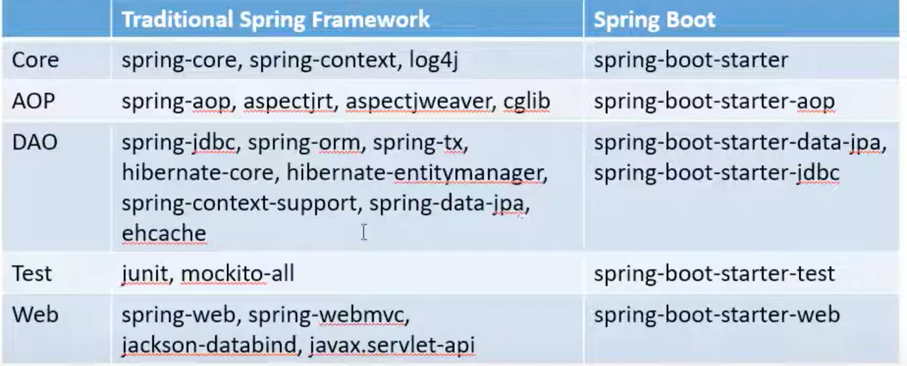

***@SpringBootApplication?***

@SpringBootApplication includes configuration, auto configuration, package scan, and child package scan.

***Find a scenario that constructor injection is required?***

The immutable class, because it has no setter method. If the immutable class wants to do injection, it must be constructor injection.

Bean configuration is singleton by default, but if we want the bean factory to return a different bean every time, we can change the scope to prototype, but it is a shallow copy.

***What are the scopes of a bean in spring?***

Singleton: returning the same instance each time, not thread safe, it is default.

Prototype: returning a new instance each time, usually used for domain objects.

Request: Each request corresponds to a unique instance of the request.

Session: each session corresponds to a unique instance of the beans.

Application: for a servlet context

WebSocket: for websocket

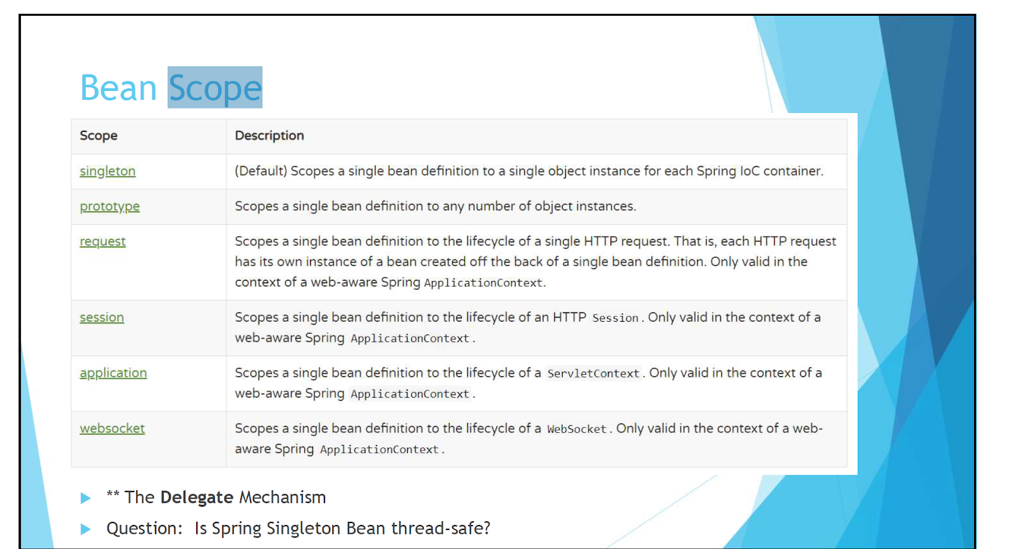

***@Configuration annotation?***

The class added @configuration on it refers to it can be used as a configure file even though it’s an original class. Then if we add the @bean annotation on the employee class, it means the employee class is managed by spring. It also can do the setter injection and constructor injection.

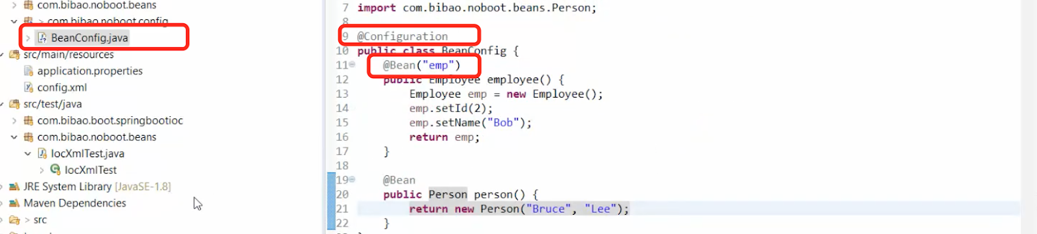

***When do you use the singleton and prototype scope?***

If you want to save data in a POJO, you can use a prototype because it needs to create multiple instances.

If you want something to represent logic like service, controller, you should use singleton.

***SPRING FRAMEWORK 2:***

***XML configuration vs Annotation configuration?***

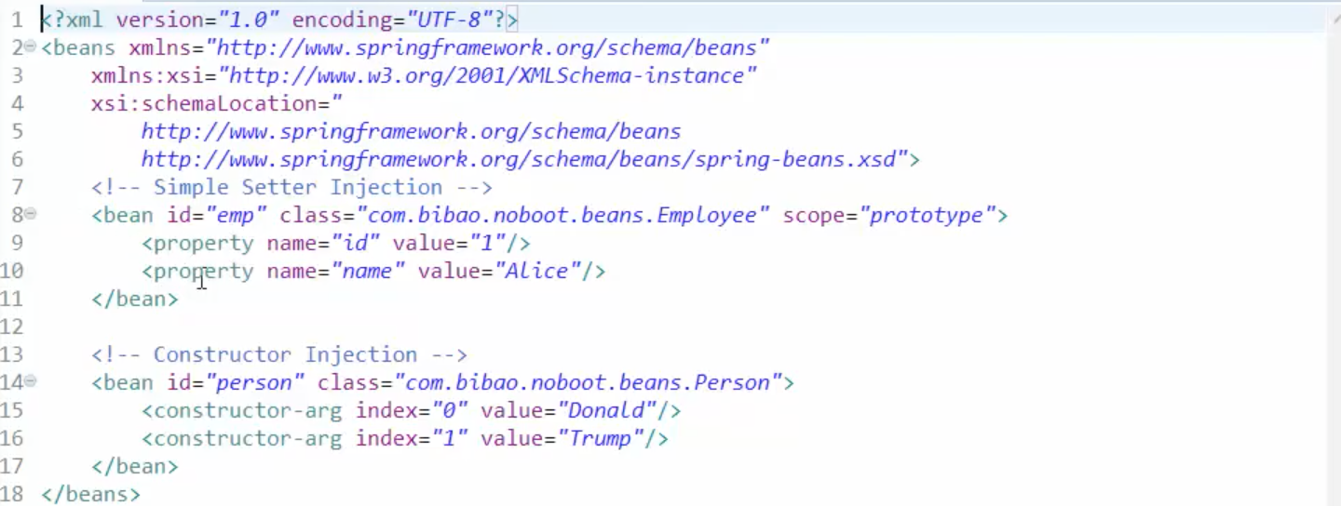

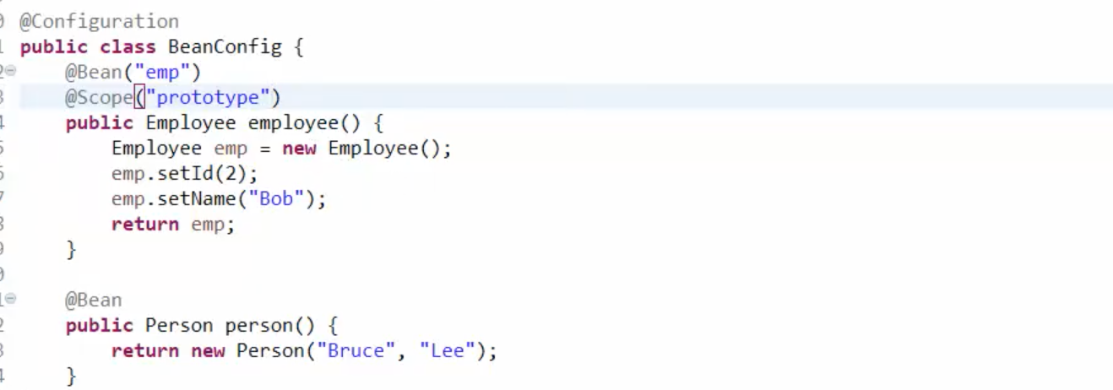

***The type of AutoWire?***

No, byName, byType, constructor.

byName: byname should work when the field name is the same as the bean id.

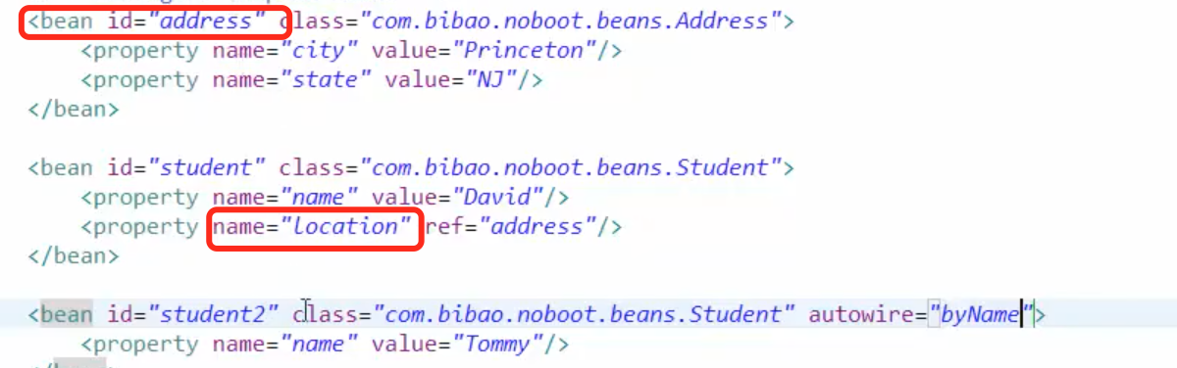

byType: it should work when the type or class of the bean is the same as the type of the field.

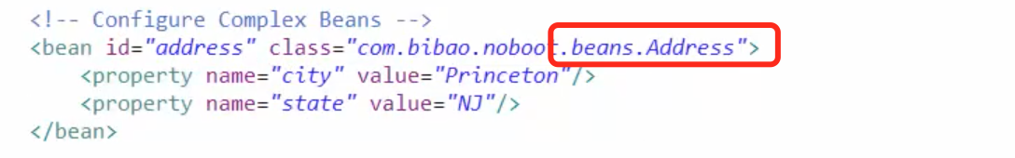



***How to configure Dependency injection?***

Use xml file configuration.

Use annotation configuration.

Use stereotype like @conponent

***SPRING FRAMEWORK 3:***

***@conponent?***

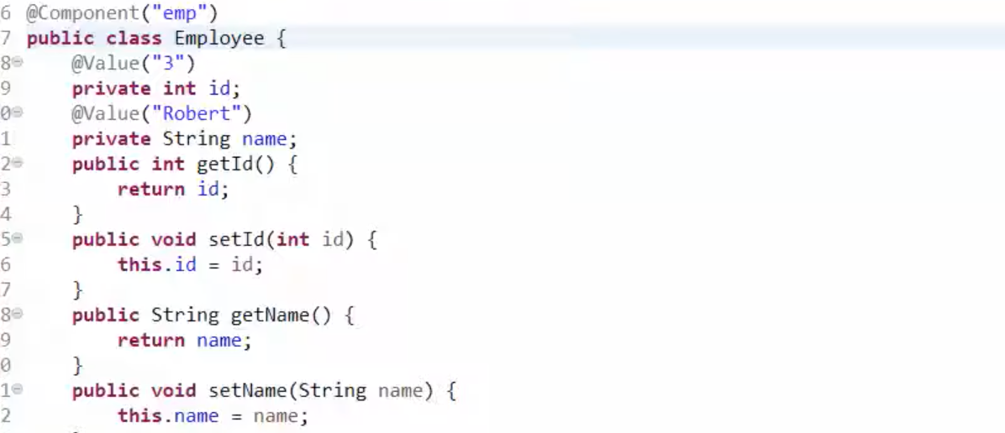

No need to new() a bean.

***How to use stereotype to manage bean in spring?***

Adding @Component on the Student class, and @Value(“jack”) on the name of the class, @autowire on the address means it will search who created a class and has a field of address in the whole environment. But how to trigger this configuration. Adding the component-scan package in the contextconfig.xml, then the environment can scan the package and know who will create this bean. Besides, we can also add the @Configuration on the class as a configuration file, then add the @ConponentScan(basePackages={“......”}) to focus the class with the @component.

How to use the data in the application properties?

Noboot: Adding the @PropertySource on the configuration class.

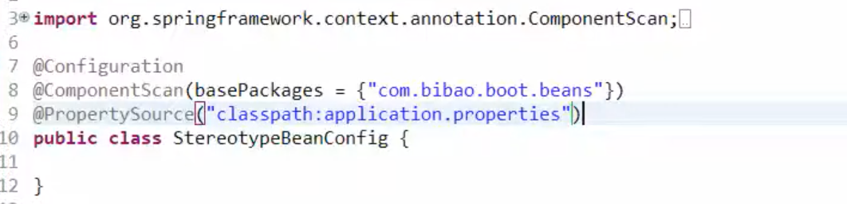

Boot: no need to add something.

***@autowire keyword?***

It checks the type first, then checks the name.

***SPRING FRAMEWORK 4:***

@Service, @Controller, @Repository?

***@Qualifier?***

This annotation is used with @AutoWire to specify which bean should be autoWired. It is useful when different beans have the same bean type. Note: the name of the bean is the name after the initial letter is lowercase. The class name of the example below is “DetailedAddress” which extends the class Address, so its name should be “detailedAddress” and the type should be Address.

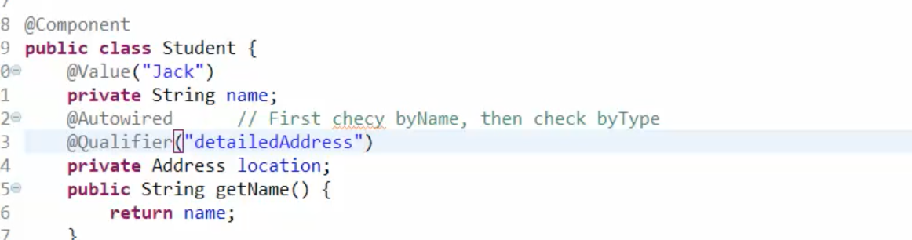

***@PostConstruct?***

The emails list cannot be assigned directly with autowire, so we use the @PostConstruct method to assign the bean after it is built.

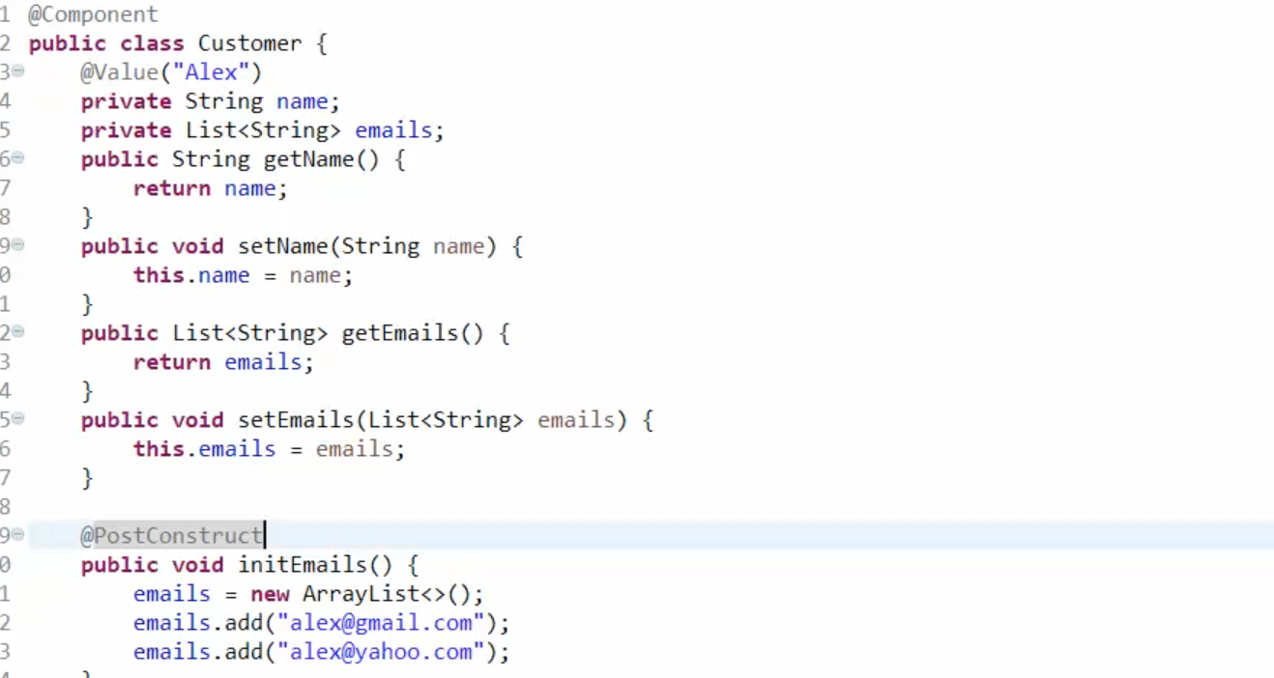

***SPRING FRAMEWORK 5:***

***What is spring AOP:***

AOP is aspect oriented programming, it can help build dependencies between two different classes. It is like a proxy. There are three components of AOP, Advice is the function to be injected, pointcut is the place where the advice can be injected. advisor is responsible for assembling the advice and pointcut. The types of advice include intercept around, before, after returning, after throw.

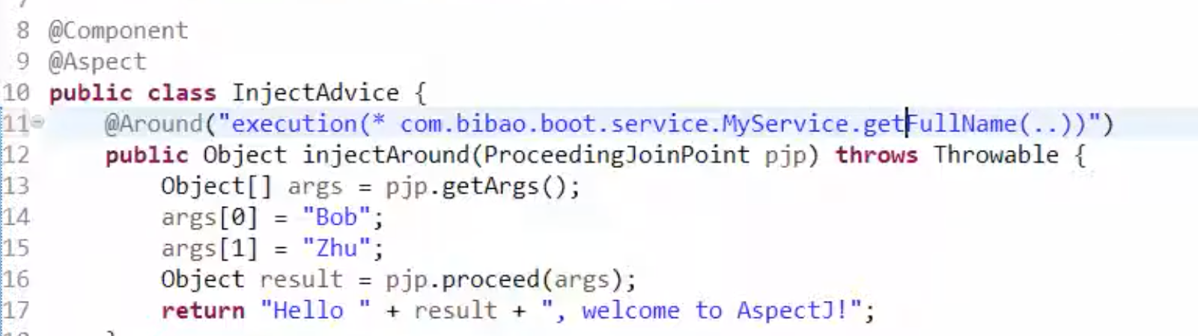

***What will the AOP be used for?***

It is easy to write the log for method executing, because AOP can intercept all methods. Besides, AOP can be used to handle exceptions, @After throw will make the code to go to the method with @afterthrow when exception occurs.

***What is the exception handler?***

It will be used in the controller. Using @ExceptionHandler(“myexception.class”) annotation on one method, it means that when myexception is thrown, the method with @ExceptionHandler() will be executed. When the exception is thrown from the DAO or Service layer, it also will be handled in the controller layer.

***SPRING FRAMEWORK 6:***

***AspectJ simplifies the AOP.***

***@Aspect***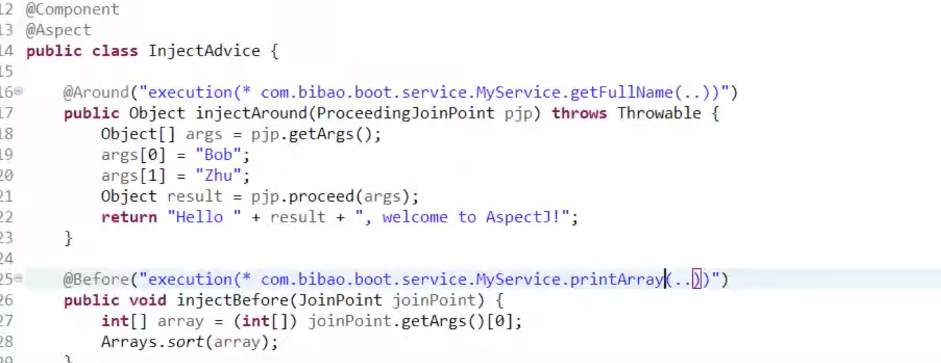

***Configure the advice setting.***

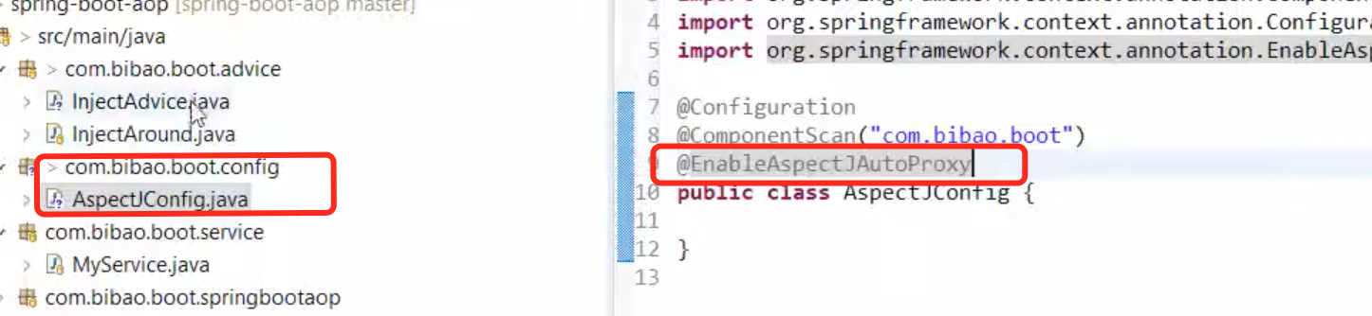

***SPRING FRAMEWORK 7，8 legacy spring: DAO/ORM/JPA.***

***Details:*** [***https://www.youtube.com/watch?v=iE3e6rxSGQ4***](https://www.youtube.com/watch?v=iE3e6rxSGQ4)

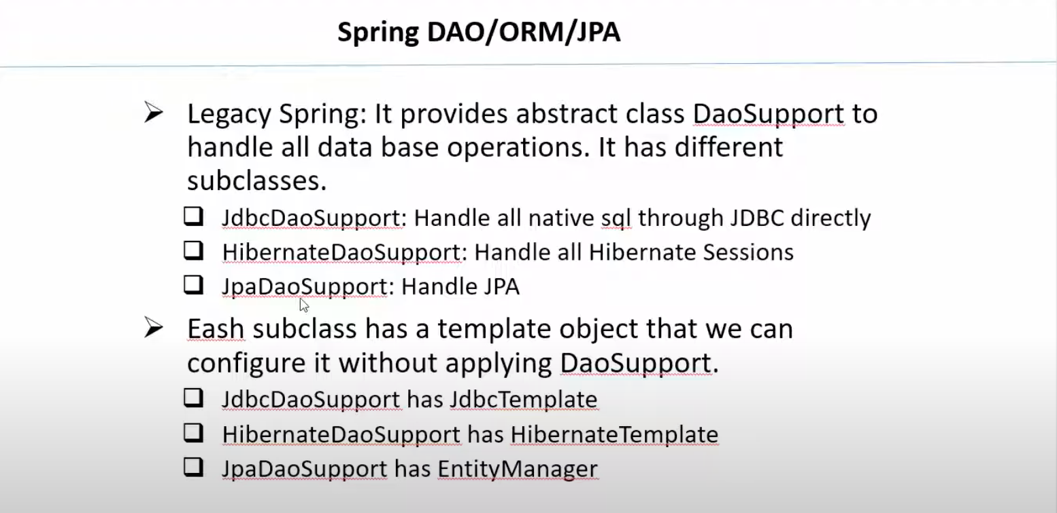

***SPRING FRAMEWORK 9 Transaction propagation:***

Transaction type:

Required: if we have outer transaction and inner transaction, using the required will make the outer one and inner one to only one transaction, if the transaction fails, all the thing will roll back.

Required_new: the transaction using the required_new annotation will be independent, if it fails, the outer transaction will not be affected.

Mandatory: if I was transactional, if you want to call me, you must also be transactional.

Never: if I was transactional, if you want to call me, you must also not be transactional.

Supports: support non-transaction and transaction.

***How to configure transaction:***

@Transactional(propagation=Propagation.REQUIRED)

***What is spring JPA?***

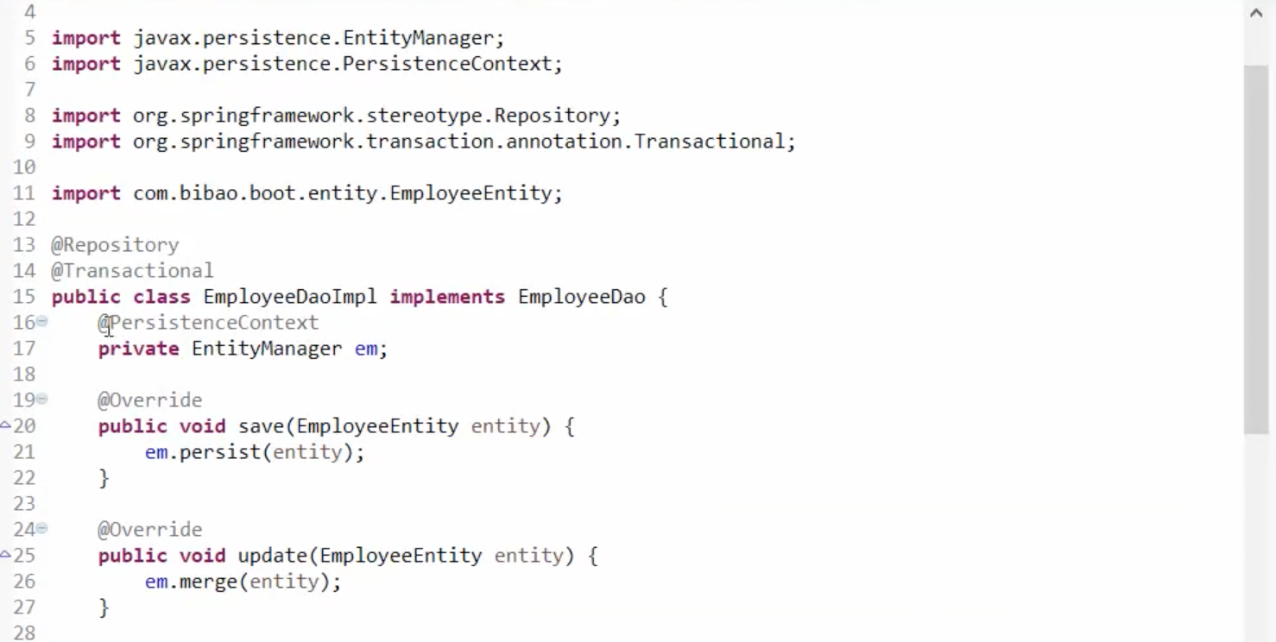

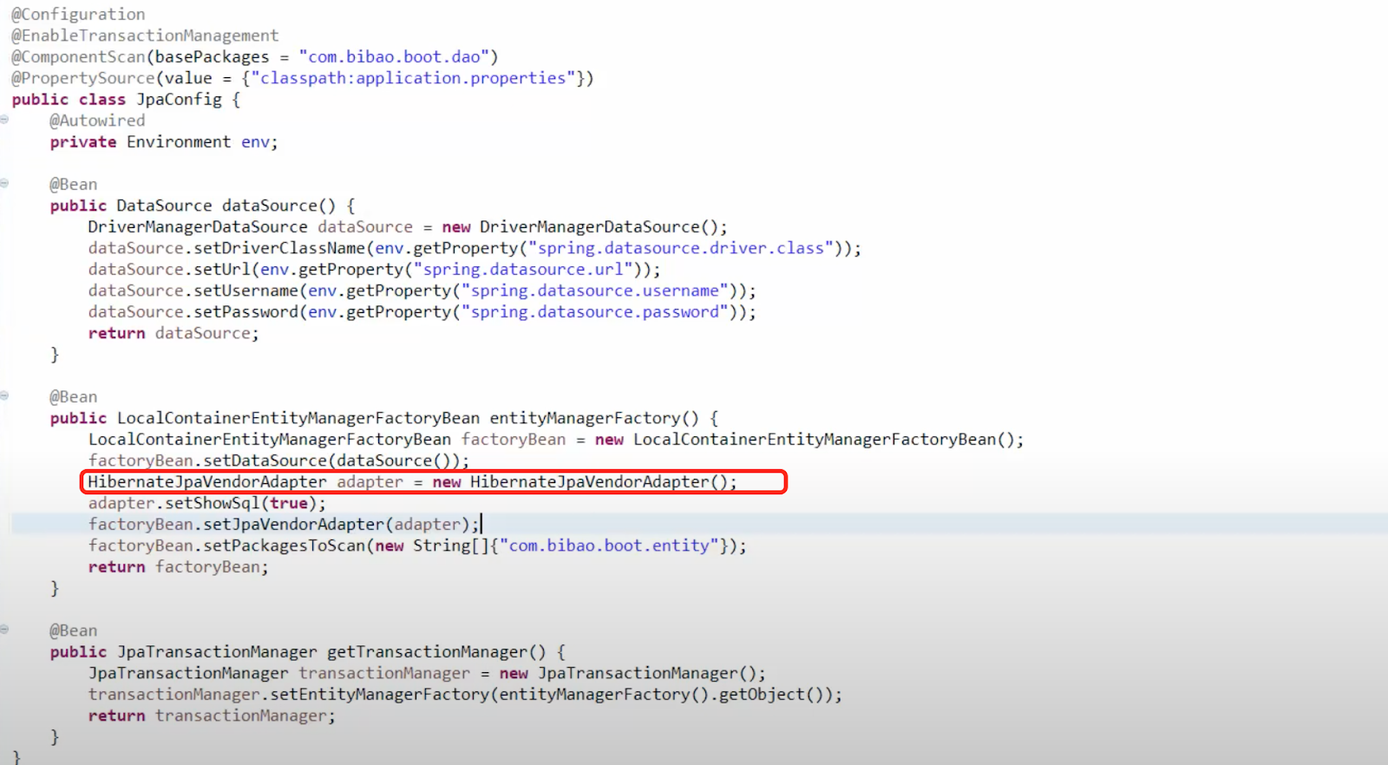

***SPRING FRAMEWORK 10:***

***How to use spring data jpa?***

The entityRepository extends the jpaRepository<>, then adding @enableJpaRepositories() in the springbootapplication file.

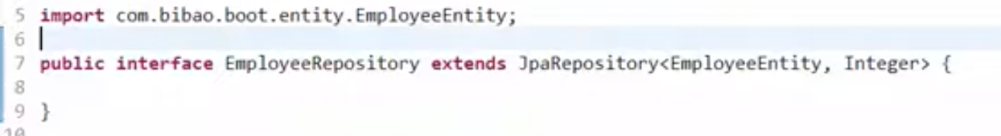

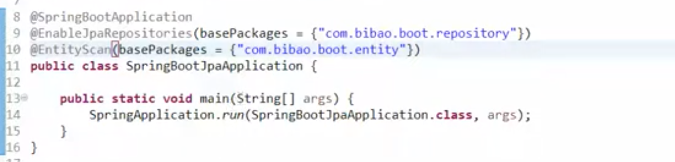

***SPRING FRAMEWORK 11:***

***Adding the naming convention style method in the entity repository, if the method is the write operation, it should be added the @Modifying and @Transactional annotation.***

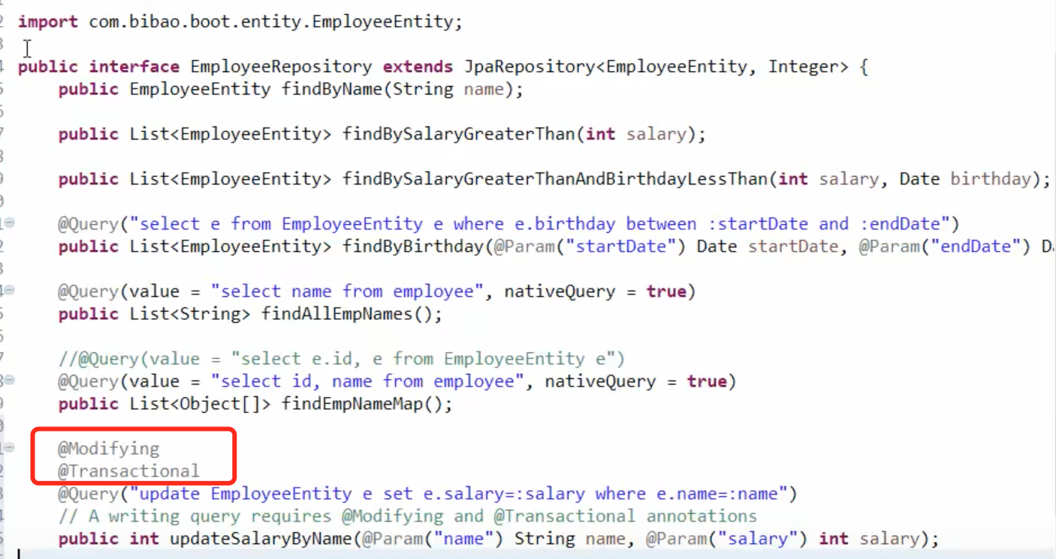

***What are the default behaviour method in the spring data entity?***

Save, update, delete, findById, FindAll.

***SPRING FRAMEWORK 12 Spring REST:***

***Why spring boot?***

Dependency injection, Simplify the configuration, build-in server.

***What is the REST?***

REST is like a black box, which can receive an input and produce a response. For example, the user interface sends a request, so the UI is as the consumer, the backend writes a response back depending on the request, the backend is as the producer. REST mainly uses JSON format to transfer data, but it also supports XML. It is more light-weighted than SOAP.

Stateless: ?

Resource-driven: get, post, put(replace), delete.

***What is SOAP?***

The mode of the transfer data through the internet previous to the REST, it uses the envelope, header, and body as a XML file, and is heavy-weighted. Java6 provides the JAXB to do marshalling and unmarshalling. Marshalling is to converts a Java Object into an XML format file, unmarshalling does the opposite thing.

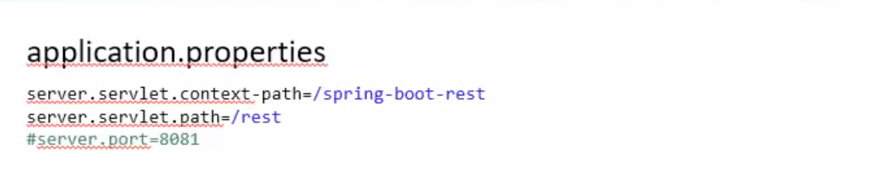

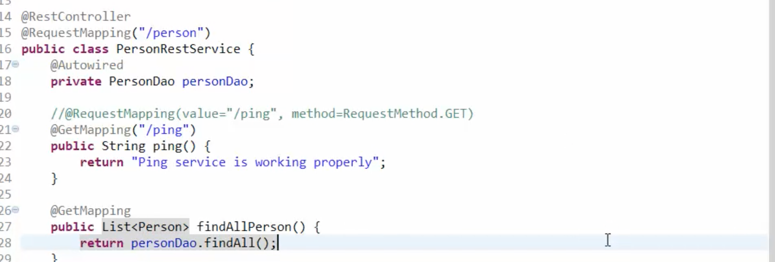

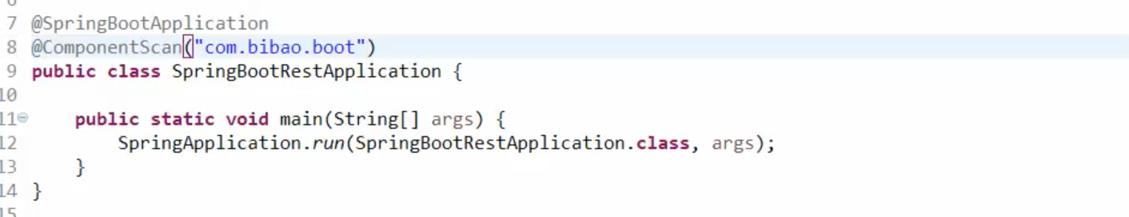

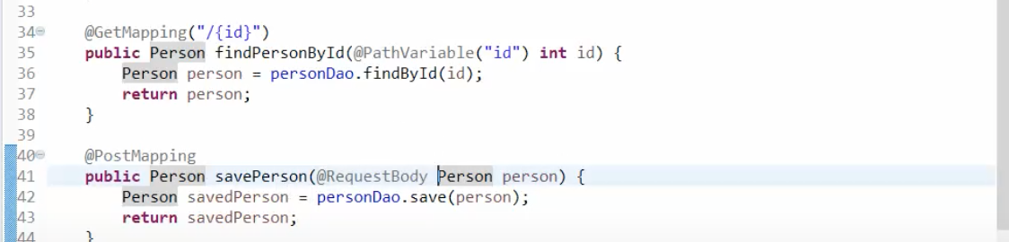

***How to test a rest api?***

Postman

Client test, using the restTemplate is to simulate a client.

Always, we need the client side test and integration test to test the rest api instead just depending on Postman.

We can analyze the response code from the rest api, like 404(not found), 403(not allowed), 401(not authenticated), 400(bad request).

If the response code is 500, which means internal server error, we should check the problem layer by layer. Like debugging the DAO, Service and controller layer.

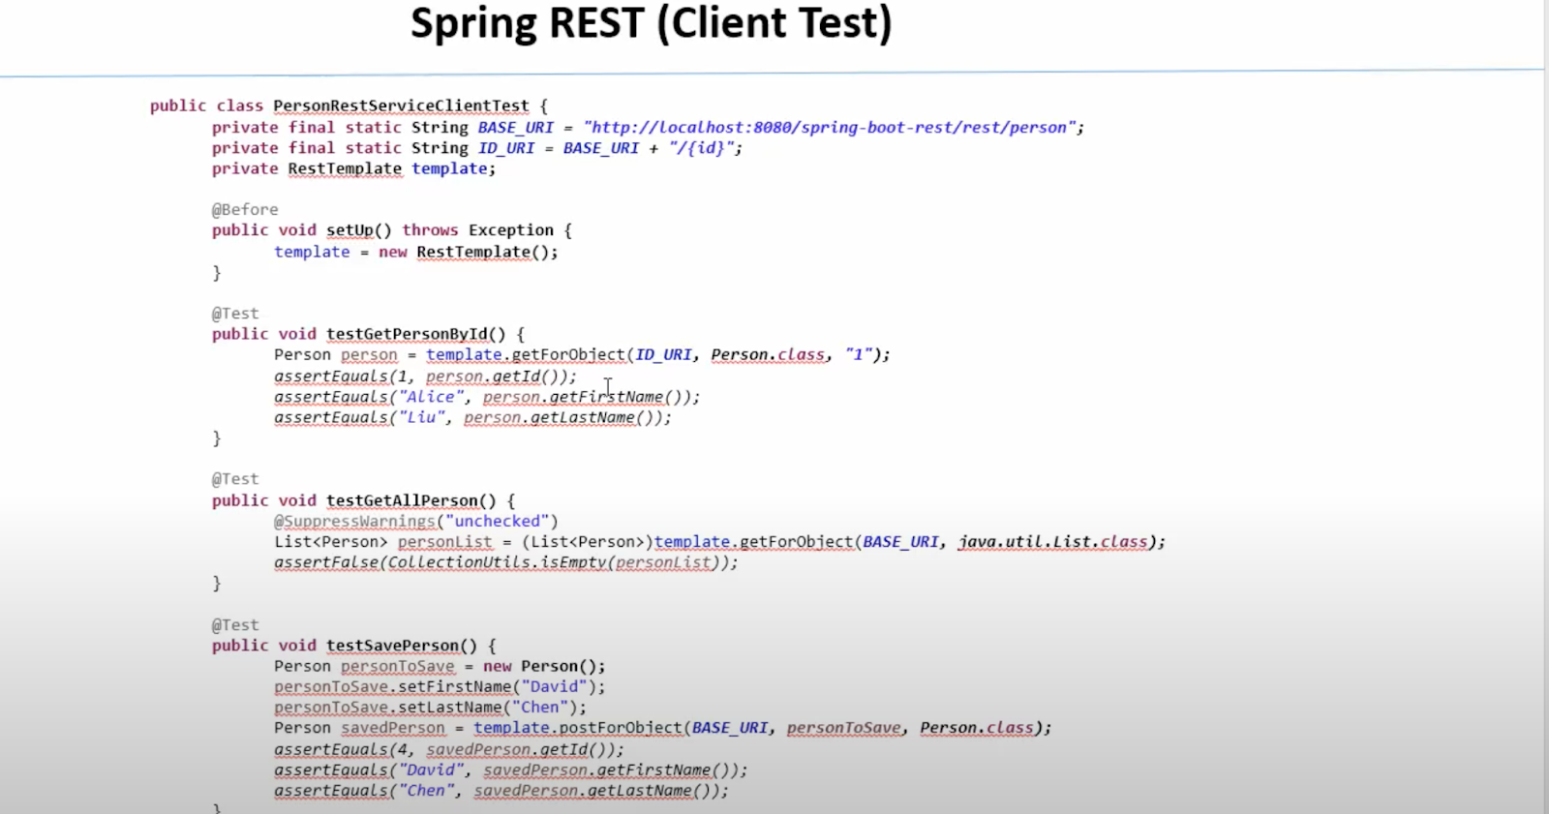

***What is an integration test?***

Integration test depends on different other modules, after running a server it will be closed. Client side tests need the server to be always running.

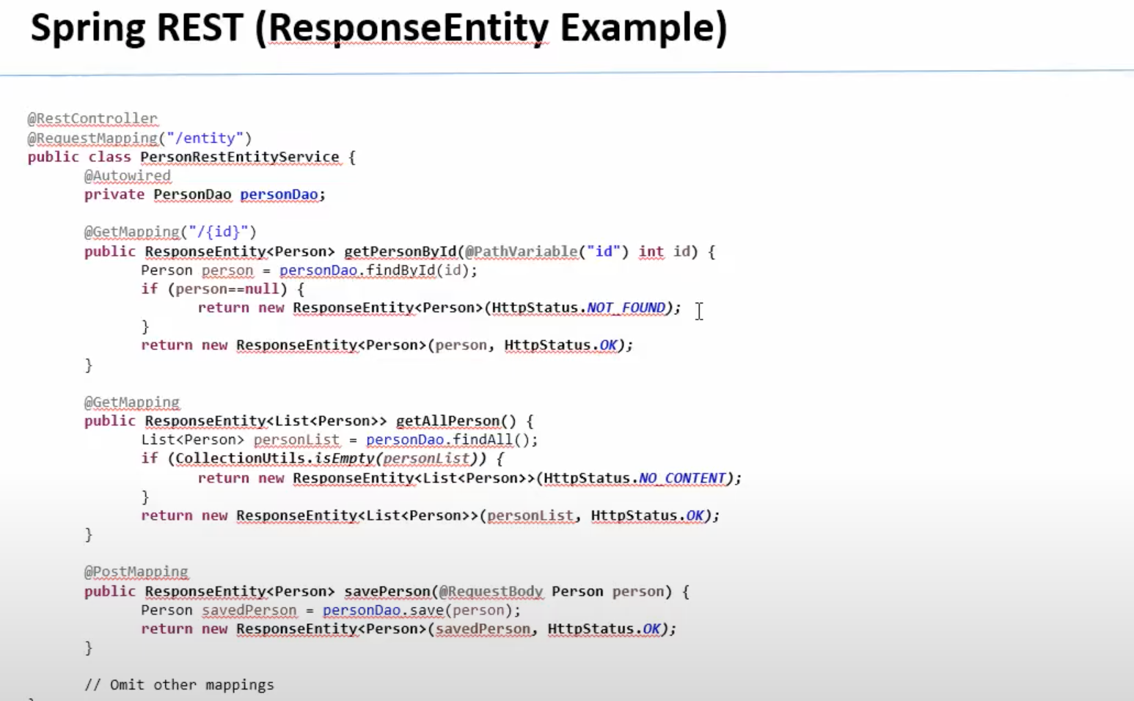

**JVM, JRE, JDK?**

**Interface vs abstract?**

**LinkedList vs ArrayList?**

1) ArrayList internally uses a dynamic array to store the elements.

LinkedList internally uses a doubly linked list to store the elements.

2) Manipulation with ArrayList is slow because it internally uses an array. If any element is removed from the array, all the bits are shifted in memory.Manipulation with LinkedList is faster than ArrayList because it uses a doubly linked list, so no bit shifting is required in memory.

3) An ArrayList class can act as a list only because it implements List only.LinkedList class can act as a list and queue both because it implements List and Deque interfaces.

4) ArrayList is better for storing and accessing data.LinkedList is better for manipulating data.

**Array vs ArrayList？**

Arrays can contain primitive or objects, while an ArrayList can contain only objects.

Arrays have fixed size, while an ArrayList is dynamic.

**garbage collection?**

garbage collection is to identify and discard those objects that are no longer needed by the application, in order for the resources to be reclaimed and reused.

**why override equals() and hashCode?**

In order to use our own class objects as keys in collections like HashMap, Hashtable etc.. , we should override both methods ( hashCode() and equals() ) by having an awareness on internal working of collection.

**What is the difference between throw and throws?**

**Throw** is a keyword which is used to **throw** an exception explicitly in the program inside a function or inside a block of code. **Throws** is a keyword used in the method signature used to declare an exception which might get **thrown** by the function while executing the code.

**error vs exception?**

Exceptions and errors both are subclasses of Throwable class. The error indicates a problem that mainly occurs due to the lack of system resources and our application should not catch these types of problems. Some of the examples of errors are system crash error and out of memory error. Errors mostly occur at runtime that's they belong to an unchecked type.

Exceptions are the problems which can occur at runtime and compile time. It mainly occurs in the code written by the developers. Exceptions are divided into two categories such as checked exceptions and unchecked exceptions.

**HashMap的实现？**

**Process vs Thread?**

A process is an execution of a program, while a Thread is a single execution sequence within a process. A process can contain multiple threads. A Thread is sometimes called a lightweight process.

**Primary Key vs Unique Key?**

Primary key must be unique, but Unique key doesn’t have to be Primary key.

**Truncate vs Delete vs Drop?**

TRUNCATE TABLE statement is a DDL command so it can not be rolled back. It is used to remove all the records from a table. It deletes all the records from an existing table but not the table itself.

DELETE is a DML Command so it can be rolled back.It is used to delete existing records from an existing table. We can delete a single record or multiple records depending on the condition specified in the query.

DROP is a DDL Command. Objects deleted using DROP are permanently lost and it cannot be rolled back. the DROP command deletes the data of the table as well as removes the entire schema/structure of the table from the database.

**View vs Materialized View?**

Views are not stored physically on the disk. On the other hands, Materialized Views are stored on the disc. View can be defined as a virtual table created as a result of the query expression. However, Materialized View is a physical copy, picture or snapshot of the base table.A view is always updated as the query creating View executes each time the View is used. On the other hands, Materialized View is updated manually or by applying triggers to it.

**Non-clustered Index vs Clustered Index?**

**Cluster index** is a type of index that sorts the data rows in the table on their key values whereas the **Non-clustered index** stores the data at one location and indices at another location. Cluster index doesn’t require additional disk space whereas the Non-clustered index requires additional disk space. One table can only have one CI, but can have multiple NCI.

**Union vs Union All?**

Union can not have duplicate records.

***Behavioural question:***

***Create a resume -> mock interview -> tech interview -> hr behavioural question interview -> marketing -> on boarding.***

1. ***Tech interview report: the report after the tech interview.***
2. ***Resume: 3-4pages.***
3. ***Years of experience: at least 6, 7years is best.***
4. ***Project: 3 American experience, 1 China project experience.***
5. ***不要用自己的电话和邮箱申请google voice***
6. ***Self introduction: 45s - 50s, 叫什么，几年java 工程师工作经验， 几个重点技术，strong什么，familiar with 什么，有哪的经验。最新的项目用的什么技术。不要过多介绍细节。***
7. ***最新项目被问最多细节：client 是谁，title 是什么， 简历上项目的3-4行，写一些general的东西，之后的bullet 写具体细节。***
8. ***Talk about your latest project: 40 - 50 s, client 是谁，用了什么技术，做了什么，不用太详细。不要按简历读， 做总结。***
9. ***时间线：opt status， expiration date. 工作经验和身份对应。***
10. ***专业写master of science***
11. ***简历项目不要太基础，like login ，register。***
12. ***Biggest challenge: 技术难点，怎么解决，怎么improve，有数据支撑。***
13. ***面试时间：as soon as possible, immediately,***
14. ***Information: 入境，毕业，身份，opt过期。***
15. ***Two way communication, 问title， site，client。***
16. ***References: 2 - 3 个，找上项目的同学，英文名字，电话，邮箱。个人经历沟通好。***
17. ***准备驾照，ead card***
18. ***Google 不出个人信息。***
19. ***Vendor call： double check 是不是做c2c， client 是谁，location在哪，面试流程几轮, 是否有coding， 项目多长时间。线上面还是线下面。重点： c2c only, work on OPT.***
20. ***如果要employer， 留marketer 的信息，电话邮箱。***
21. ***准备question问client，根据聊天，client产品。***
22. ***可以share的只有 ead card 和 driver licence***
23. ***面试时间回复，和老师约support时间。***
24. ***为什么离开上一个项目，项目结束了***
25. ***只能share ssn 后四位。***
26. ***Manager name: 学校教授名字。***
27. ***Github: 不太靠谱就关了，comfidential， 要有东西说。***

***Quiz 1:***

***11. If you define a customized “Student” class (id, name, age, address) and you want to save it to a hashmap as map key, what do you need to do in the Student class? Write Java program to show your implementation, Assume Student is differentiated by the id and name;***

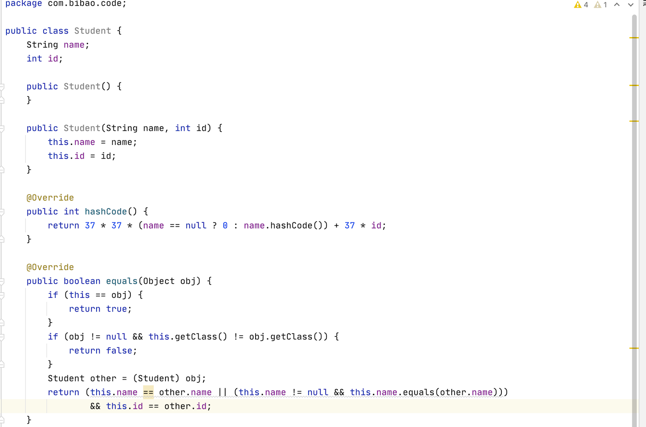

***16. What is an ExecutorSerivce? Given an example of how you have used ExecutorService in practice.***

[***https://howtodoinjava.com/java/multi-threading/executor-service-example/***](https://howtodoinjava.com/java/multi-threading/executor-service-example/)

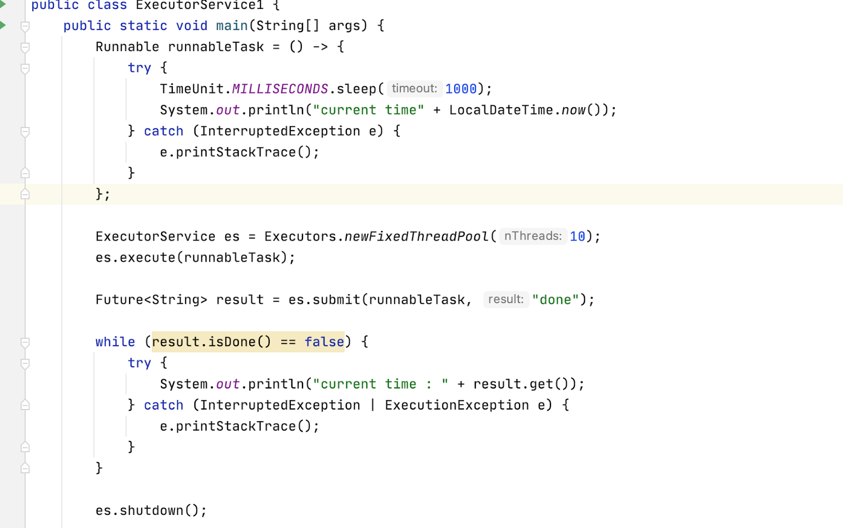

***17. Given an ArrayList including all US states, Write a program to return all states starting with letter “N”, for example, New Jersey, New York etc.***

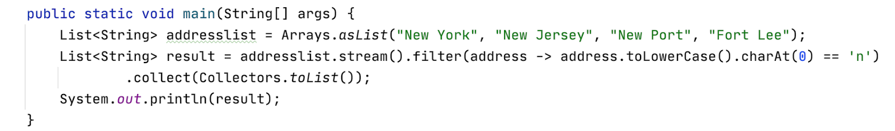

***19. Given an “Employee” table including columns: id, name, department, salary. Write a SQL to find the total salary for each department. Your result should 1) include two columns with column name as: Department and TotalSalary; 2) Only show results with total salary more than 2000; 3) sorted in descending order according to department.***

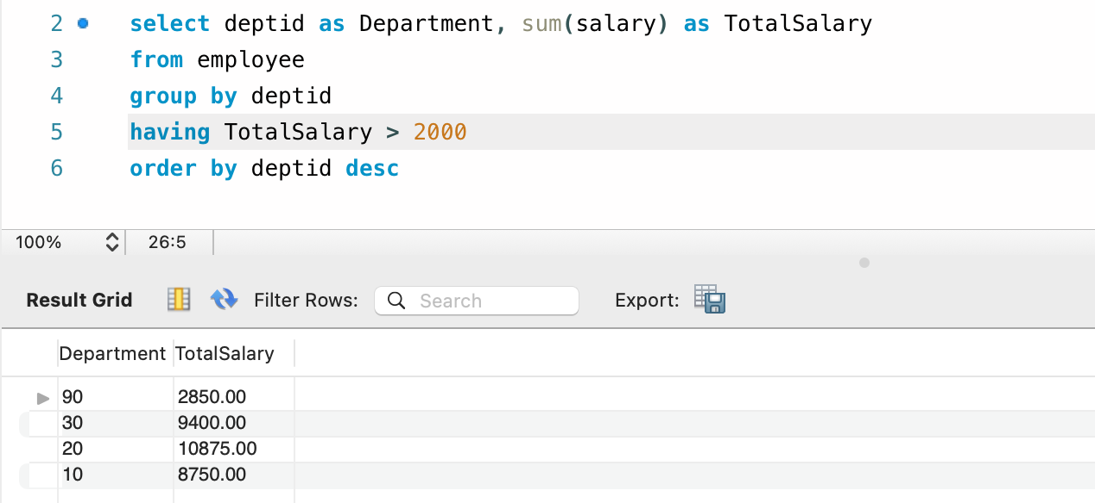

***21. Difference between git rebase and git merge***

merge commit represents every change that has occurred on feature since it branched from master. Clean and simple.

[***https://stackoverflow.com/questions/16666089/whats-the-difference-between-git-merge-and-git-rebase/25267150***](https://stackoverflow.com/questions/16666089/whats-the-difference-between-git-merge-and-git-rebase/25267150)

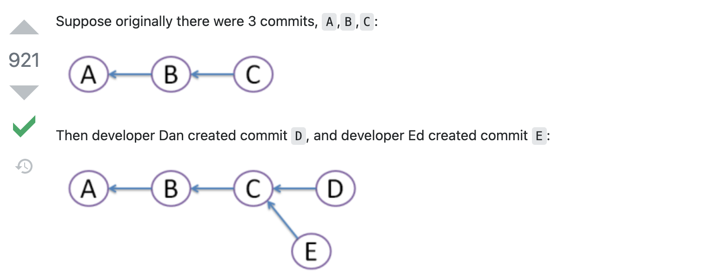

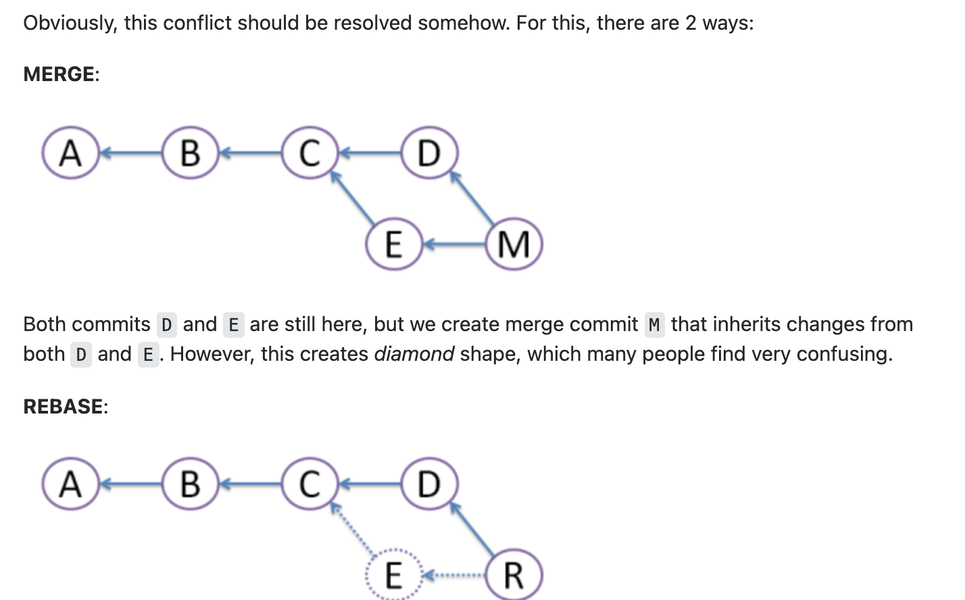

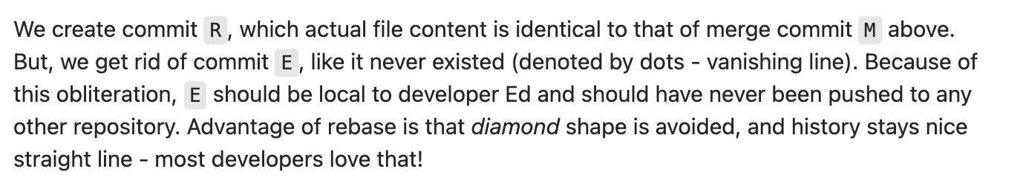

***23. Write a program to reverse a string.***

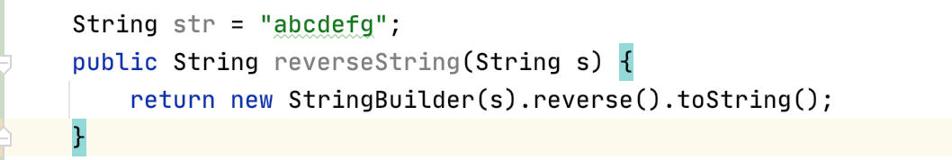

***Quiz 2:***

***3. How do you make sure your REST service can return both JSON and XML format data?***

***Produces = {“aplication/json”, “application/xml”}***

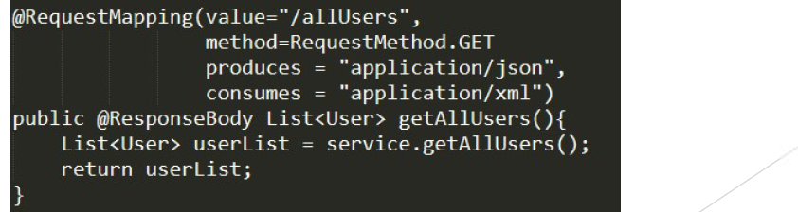

***5. What is CORS issue and how do you resolve it?***

***@override addCorsMappings(CorsRegistry registry) {***

***registry.addMapping(), add allowedOrigins, also can add allowed methods.***

***}***



***13. How do you create a b Describe the steps.***

1. ***Goes into the spring initializr website to start a project, select maven project, java version, group id, artifact id, then add needed dependencies of web, jpa.***
2. ***Decompress the package we got from the website and use intelliJ to import the file directory then we have a brand new one spring boot project.***

***14. Following Problem 13, in the spring boot project, You are given URL:***

[***http://catalog-es-service.prod.walmart.com/es-service/product/0212/search?sourceId=all&logloc=stack011***](http://catalog-es-service.prod.walmart.com/es-service/product/0212/search?sourceId=all&logloc=stack011) ***in which, 0212 is product sequence, sourceId is product source, logloc is production location Write a controller (“ItemViewController”) and retrieve the product information. Suppose the***

***product class and service class have been created for you. Add all annotations.***

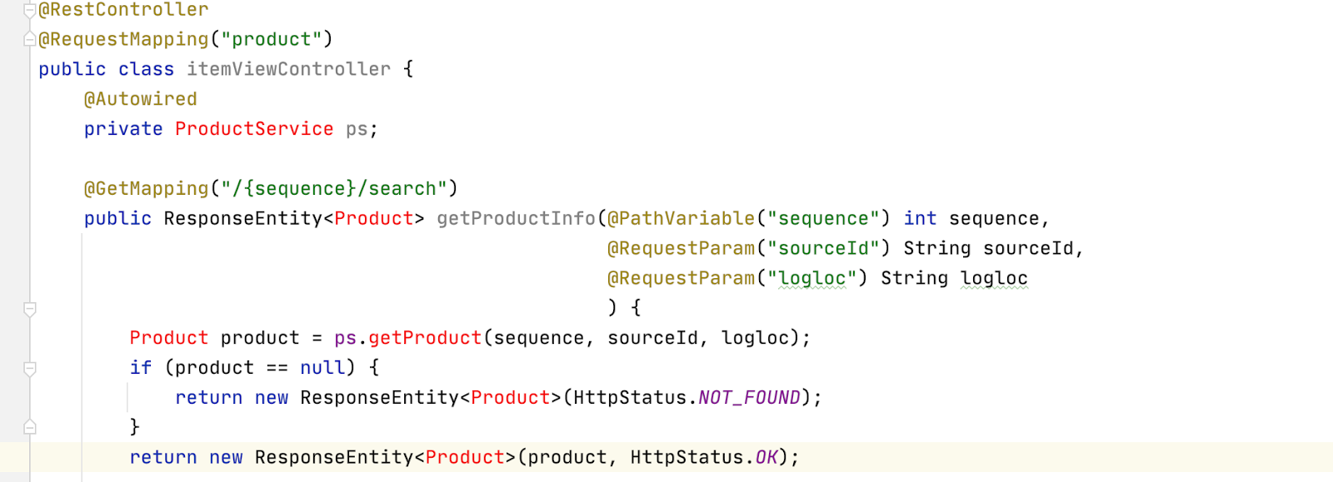

***15. Following Problem 14, Write the service(ItemViewService) class and delegate the logic to DAO (ItemDao) class method. You will need to inject the Dao class to this service. Add all annotations.***

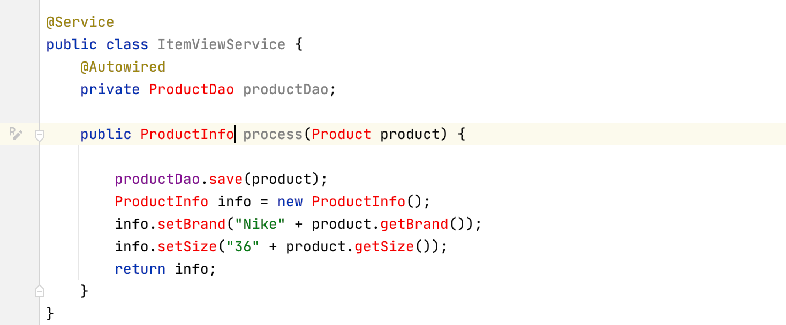

***16. Following Problem 15, suppose you are injecting a helper(ItemViewHelper) class into the service class. Use XML and annotation separately to define and inject the helper class into service class. Do not mix XML and annotation.***

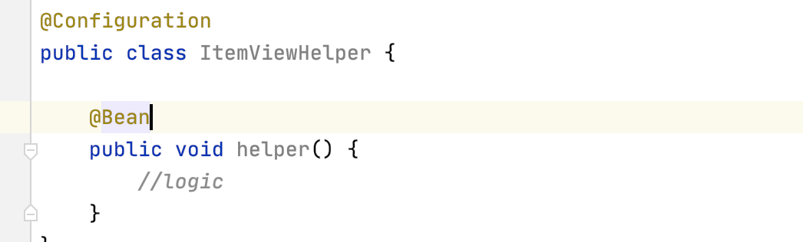

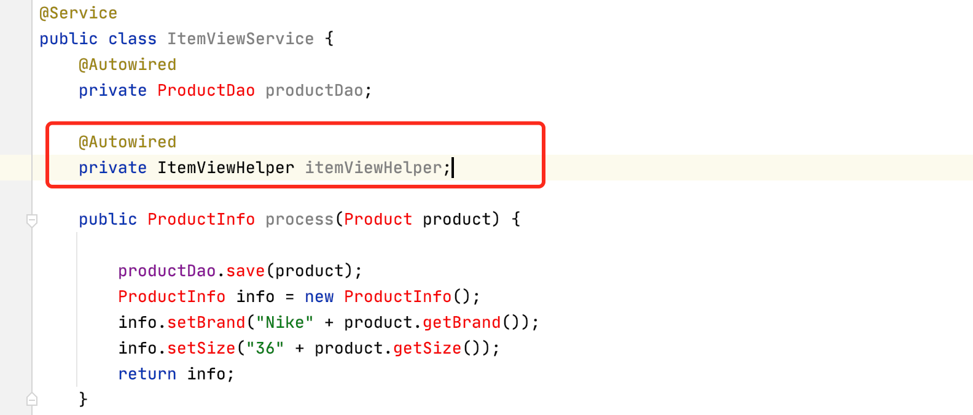

***(大概这个意思)***

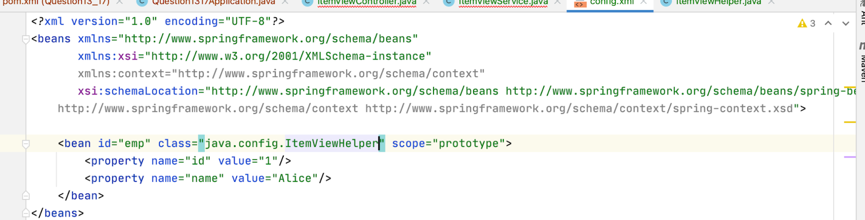

***17. In spring boot application.properties, there is an entry defined as: walmart.es.service=financial Write a complete code to get the value “financial” in service class.***

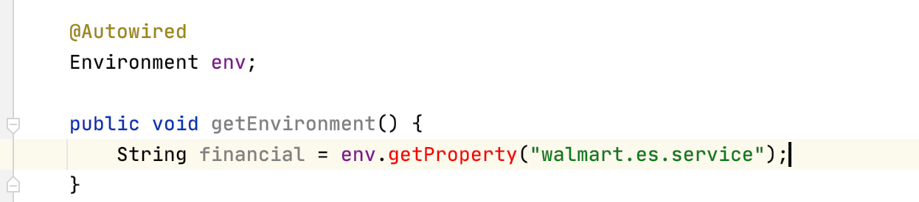

***Quiz 3:***

***1. What is the difference between JDBC Statement and PreparedStatement?***

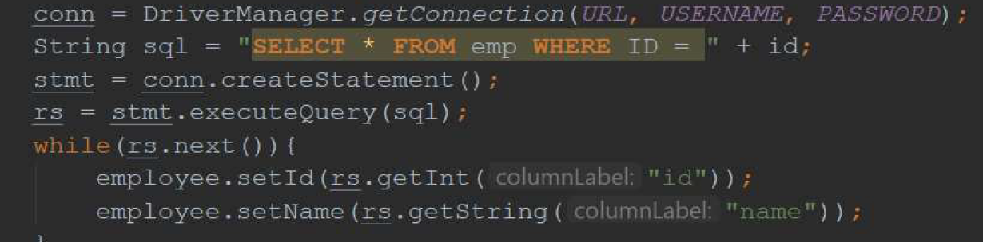



***2. When using Spring JdbcTemplate query function to retrieve data from database, how do you convert the result into Java model class object?***

*To map query results to Java objects by implementing the RowMapper interface.For example, for every row returned by the query, Spring uses the row mapper to populate the java bean:*

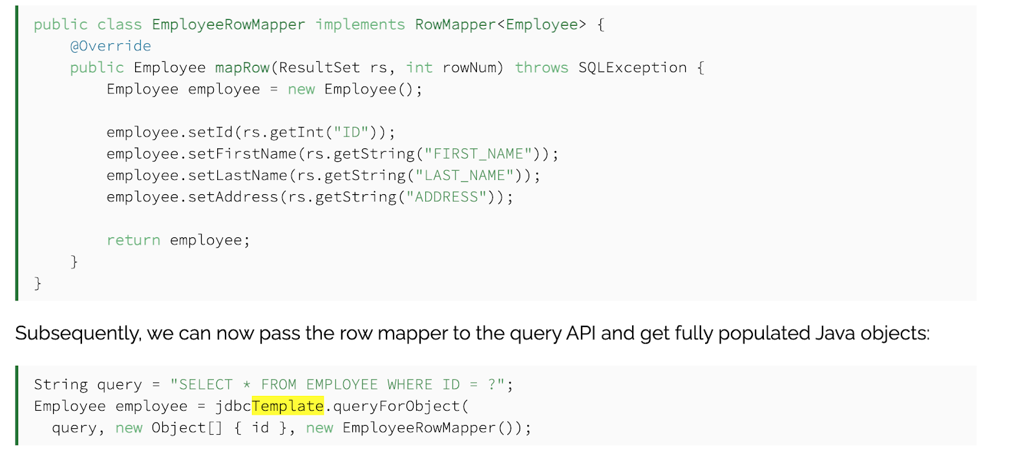

***3 Why do we need NamedParameterJdbcTemplate since there is already JdbcTemplate?***

[***https://stackoverflow.com/questions/16359316/namedparameterjdbctemplate-vs-jdbctemplate/16362128***](https://stackoverflow.com/questions/16359316/namedparameterjdbctemplate-vs-jdbctemplate/16362128)

*When you use JdbcTemplate you give it SQL that has a ? placeholder for each parameter you want substituted into the SQL. When you assign parameters in the code you have to pass in arguments in an array and they get used in the order in which they appear in the array, like this:*

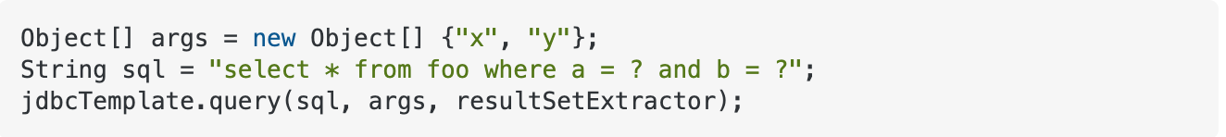

*so the SQL that gets run is select * from foo where a = 'x' and b = 'y'.*

*NamedParameterJdbcTemplate allows you to assign names to the parameter placeholders and pass in a map so the template can match the map names to the placeholders. So your code would look like:*

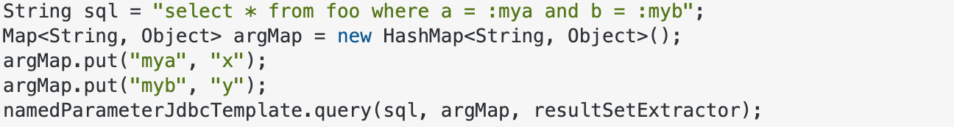

*generating the same SQL as the first example.*

*Running the query is the time-intensive part, the performance of the argument insertion is a non-issue.*

*The idea is that matching the arguments by name is less error-prone than having to specify them in a particular order. In real-life applications I've worked on, typically we store the SQL in a separate file from the DAO code, and it may be easy to accidentally get the parameters in the wrong order.*

***4. Given the following Database Table, create the corresponding hibernate/JPA mapping class？***

***JPA/Hibernate:***

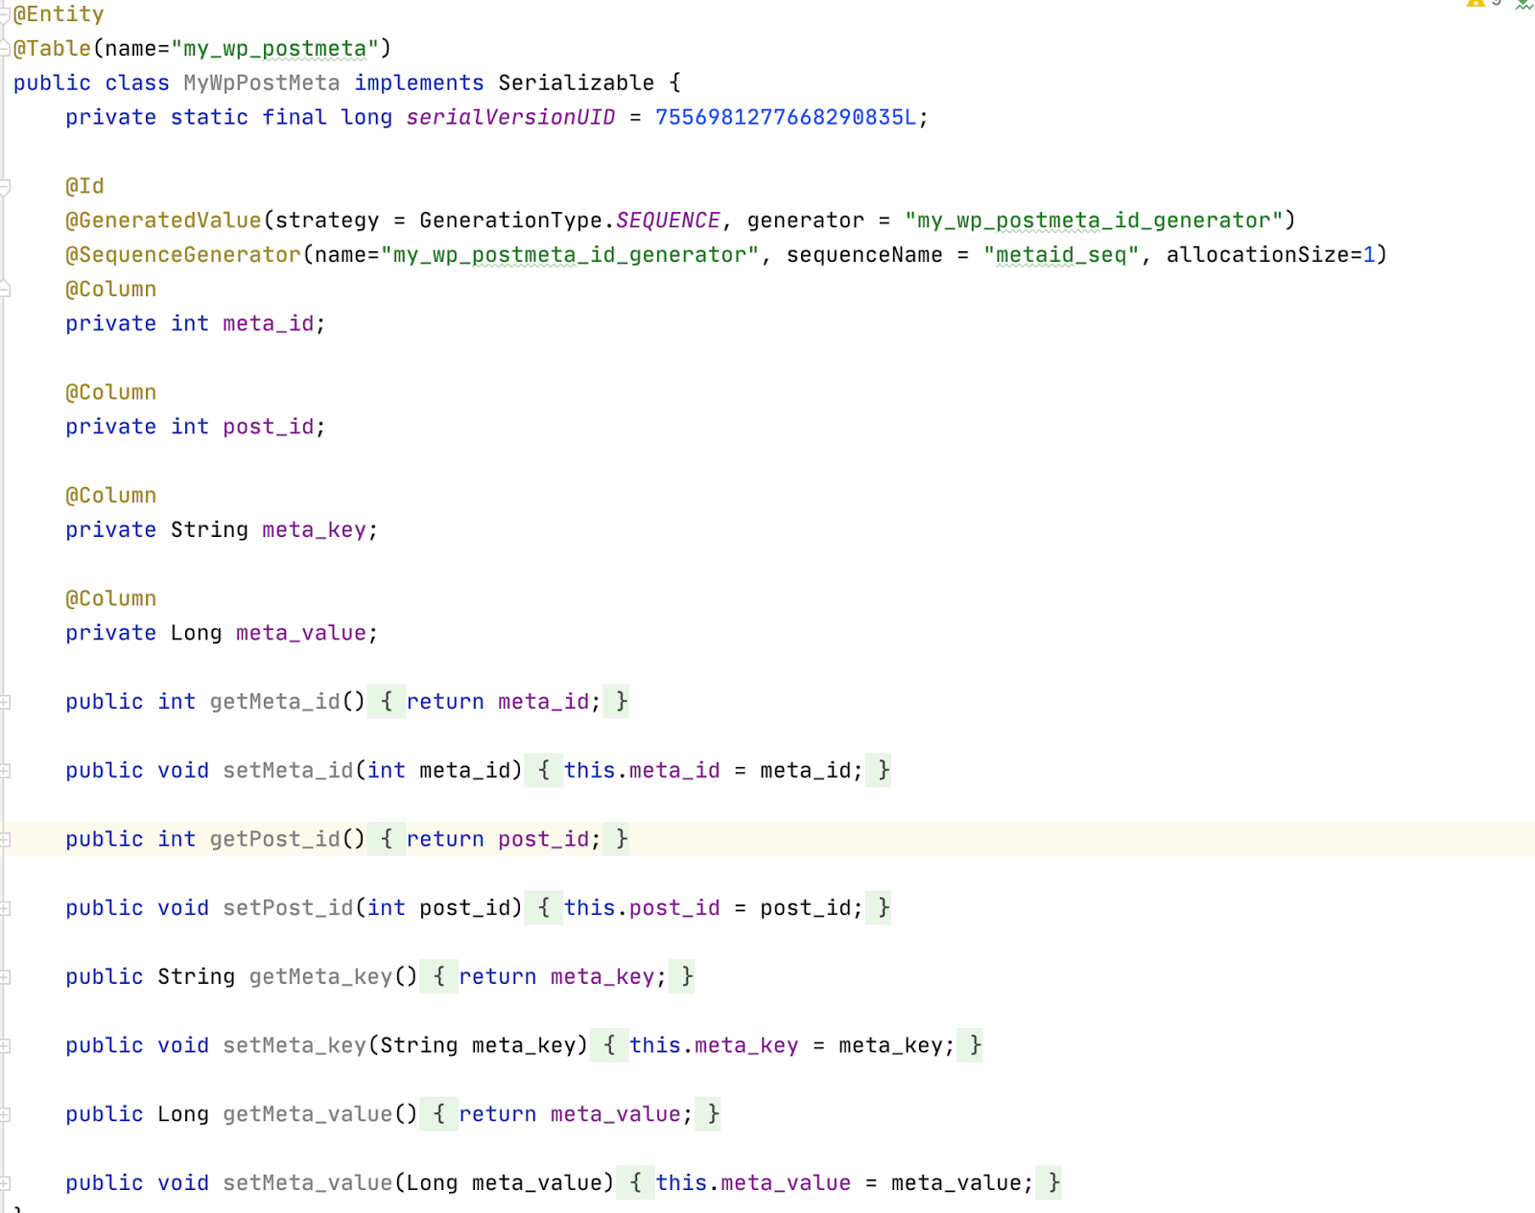

***6. Given the following relationship in database, Is this a “one-to-one”, “one-to-many” or “many-tomany” relation? Write Hibernate mapping classes to reflect this relation with proper annotation.***

On the control side we should add the @joinTable() in which add joincolumns, inverseJoinColumns. On the being controlled side, we add the mappedby=”stocks” which means the class is controlled by the class who holds the stocks field. Note that, we can only use the control side to do the CRUD operation, it is not a symmetric relation.

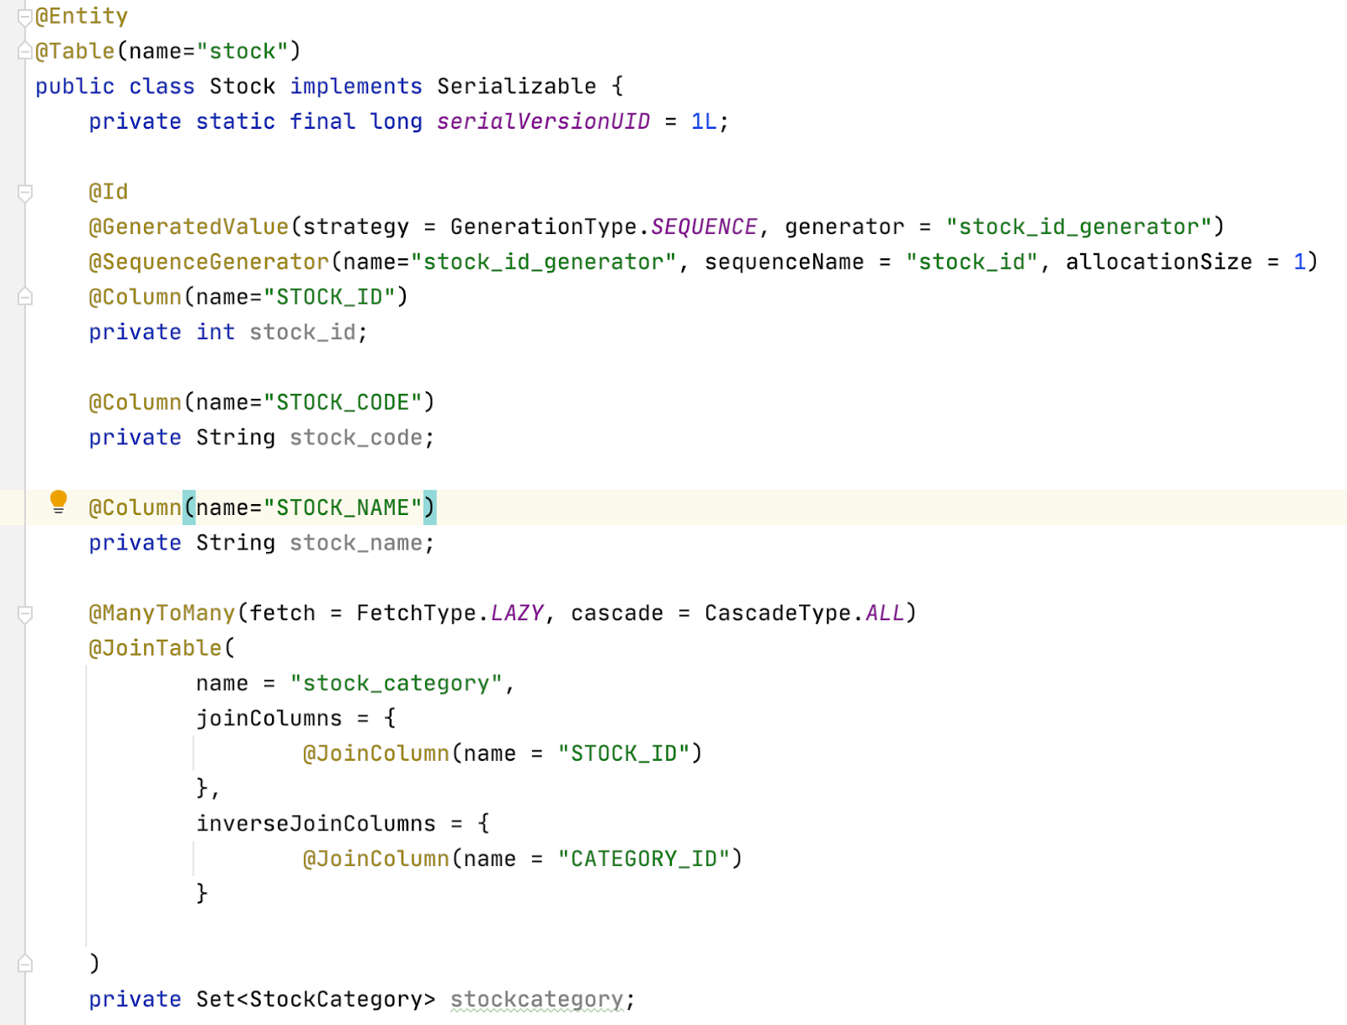

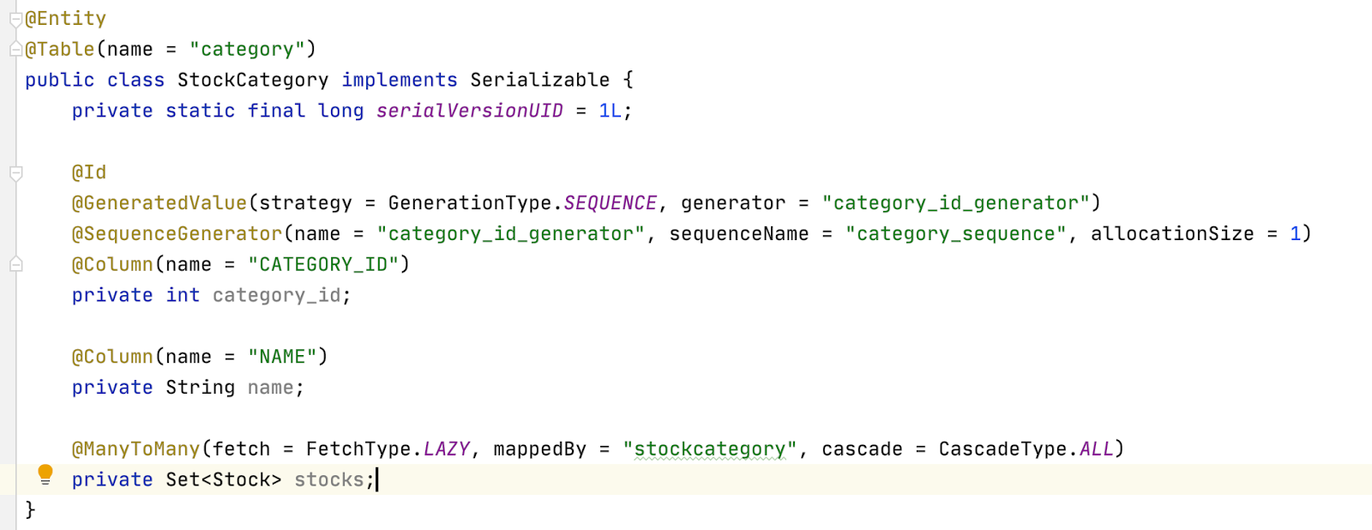

***8. List the Persistence context in hibernate and explain the meaning of them.***

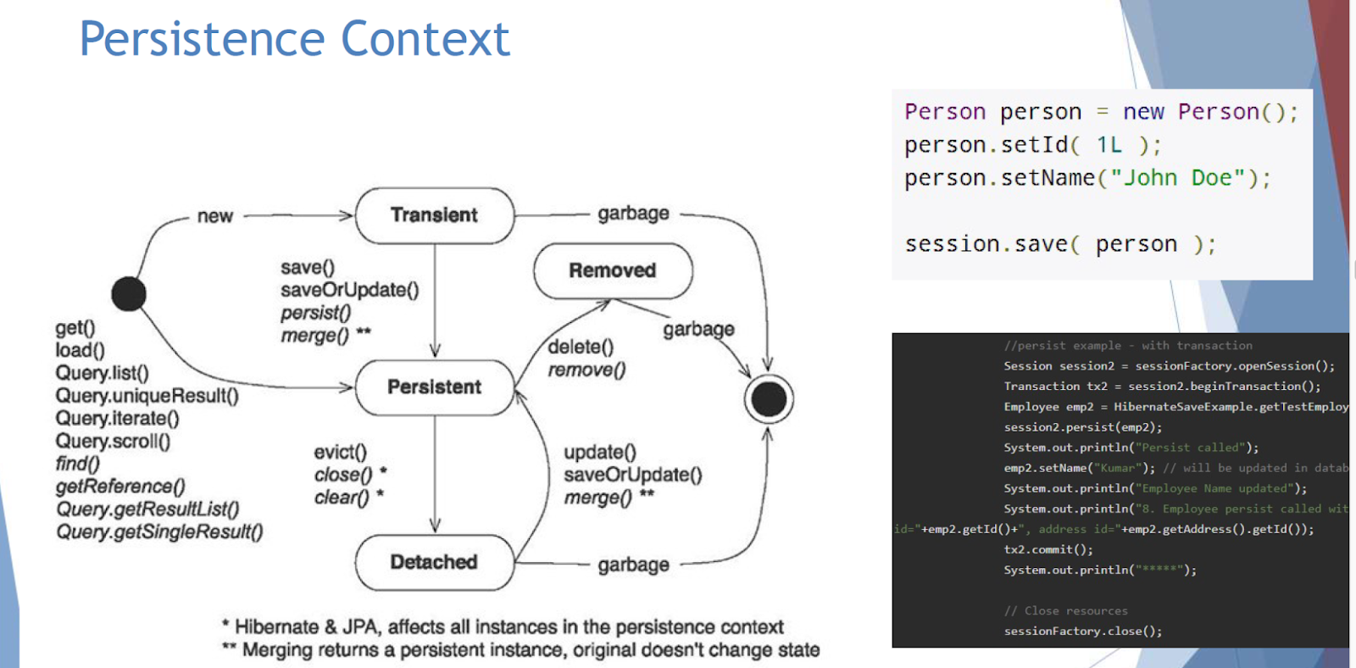

What is the transient, persistent, and detached status in a session?

Transient means the object is not related to the session.

In the persistent status, the object builds the relation with the session by the object id.

In the detached status, the session knows the object but the object is not in the session.

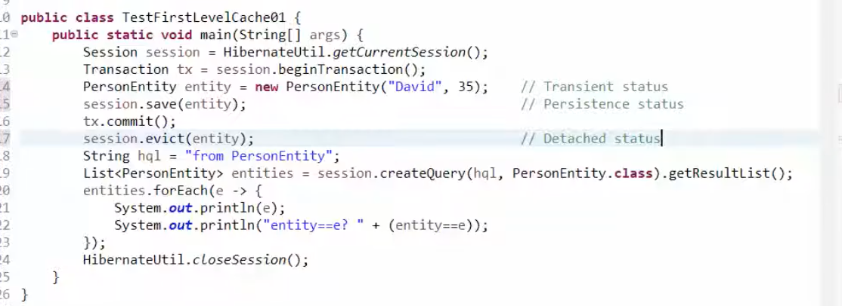

***10. You are given a “product” table in database. Now you need to read the product table and update the product “amount” field. In the meaning time, there is another thread trying to update the product amount field as well. How do you make sure that the field you are trying to update is not already updated by the other thread? Describe the Hibernate Option.***

1. Adding @Version annotation on the field of version, which will be used as a timestamp that will be checked before transaction update the corresponding row in the product table.
2. Adding @optimisticLocking and @DynamicUpdate annotations on the product class, then creating a Timestamp field with @Column annotation in which name is “created_on”, the Timestamp field can be used in the same way as the stamp used above.

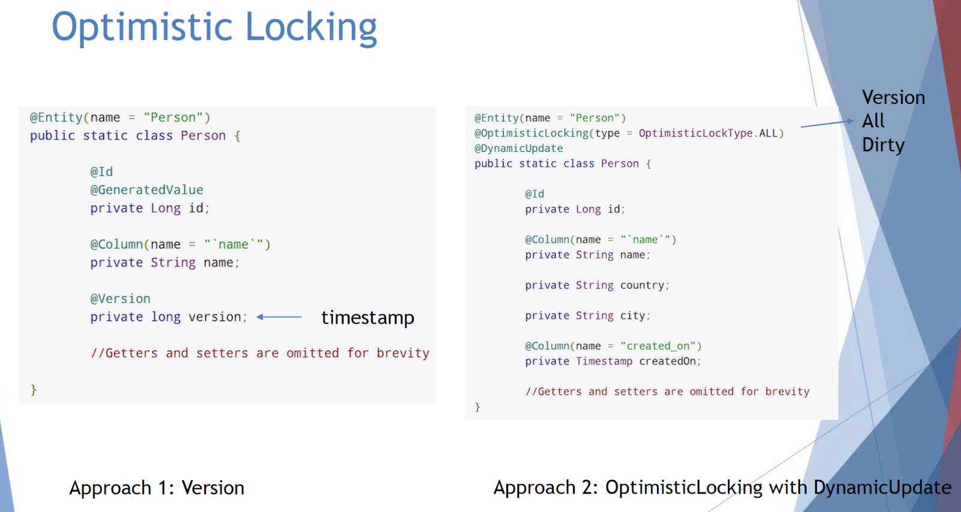

***13. What is hibernate Fetch Type and Cascade?***

Cascading is the way to achieve this. When we perform some action on the target entity, the same action will be applied to the associated entity.

Cascade type:

ALL

* PERSIST
* MERGE
* REMOVE
* REFRESH
* DETACH

when you define a relationship in Hibernate, you'll also need to define the fetch type. The fetch type essentially decides whether or not to load all of the relationships of a particular object/table as soon as the object/table is initially fetched.

Fetch type: Lazy and Eager. By default, Fetch type would be Lazy. FetchType.

What is the limitation of the Mockito?

It cannot mock constructors or static methods. It requires Java version 6 plus to run. It also cannot mock equals(), hashCode() methods. VM mocking is only possible on VMs that are supported by Objenesis.

|  |
| --- |
| Can you mock a static field using Mockito? |

I think the reason may be that mock object libraries typically create mocks by dynamically creating classes at runtime (using [cglib](http://cglib.sourceforge.net/)). This means they either implement an interface at runtime (that's what EasyMock does if I'm not mistaken), or they inherit from the class to mock (that's what Mockito does if I'm not mistaken). Both approaches do not work for static members, since you can't override them using inheritance.

|  |
| --- |
| How to test a private method without other framework? |

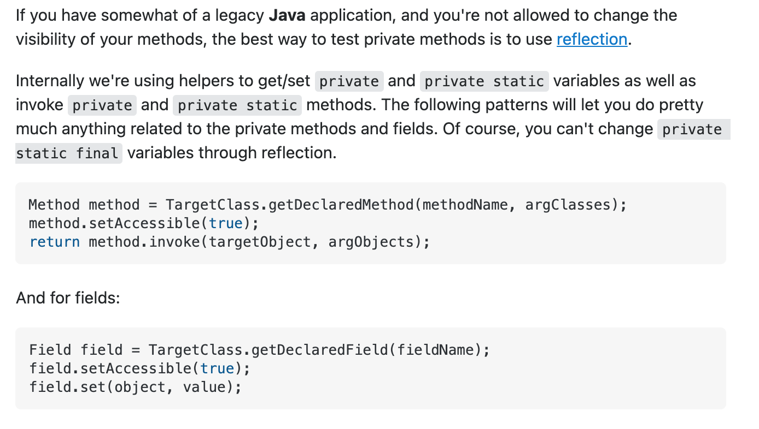

|  |
| --- |
| Cucumber and its annotations / How cucumber works, give an example |

